
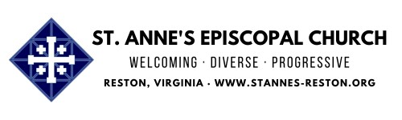
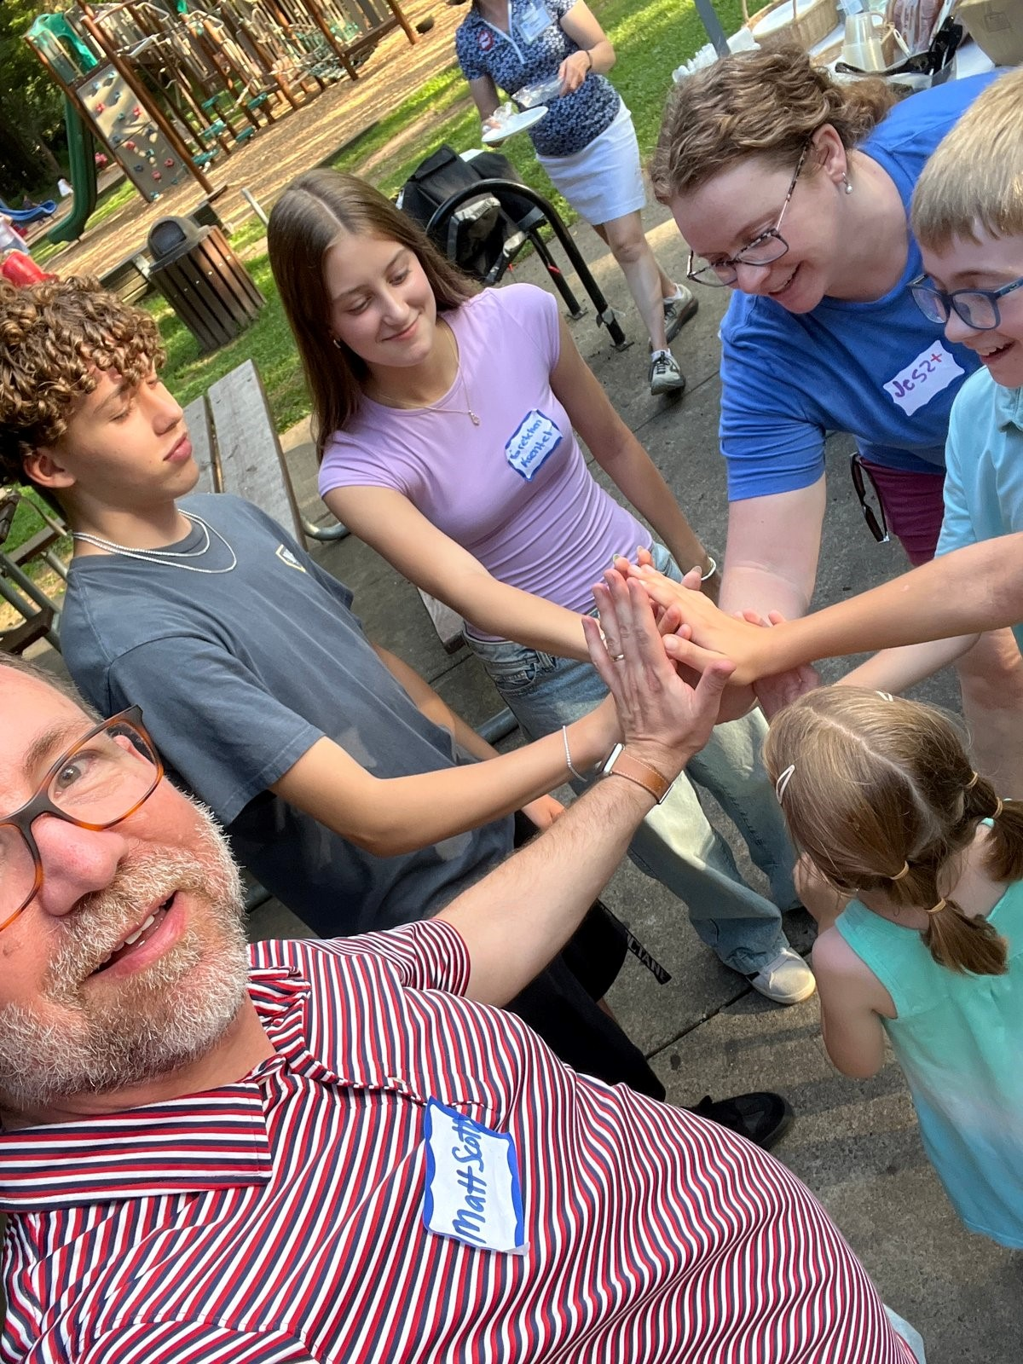
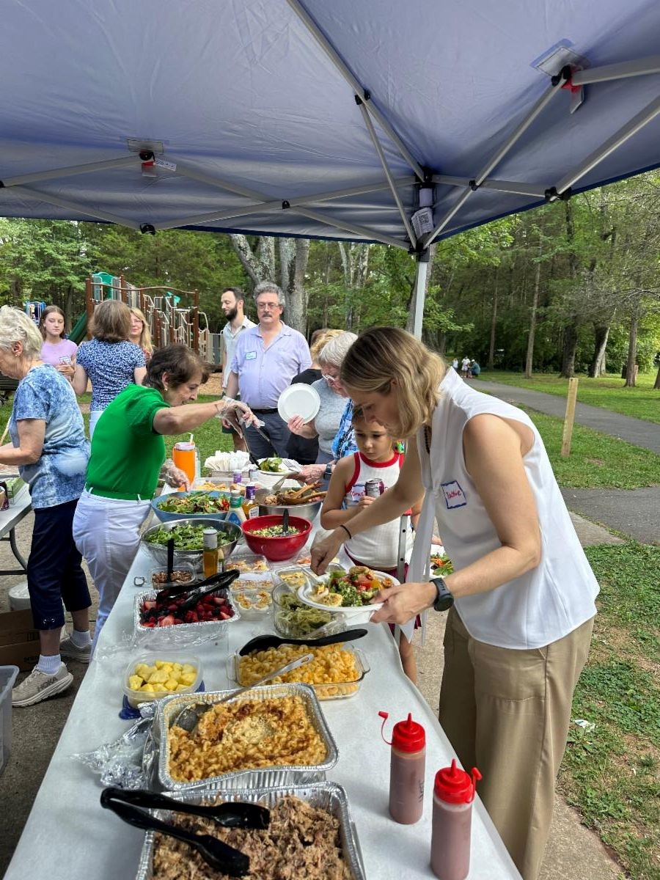
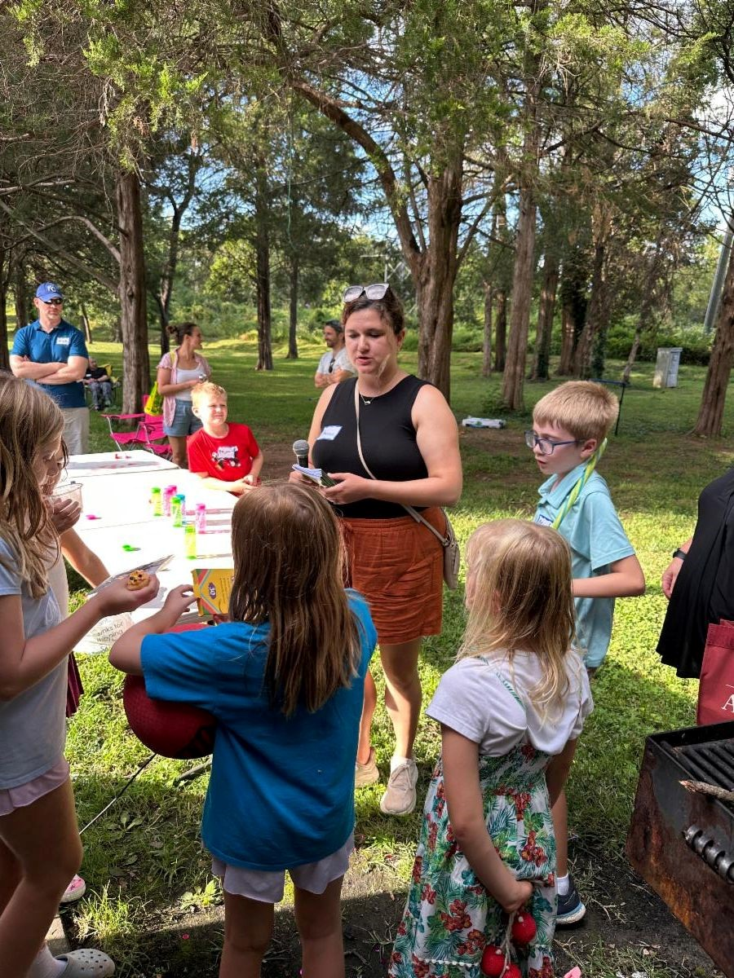
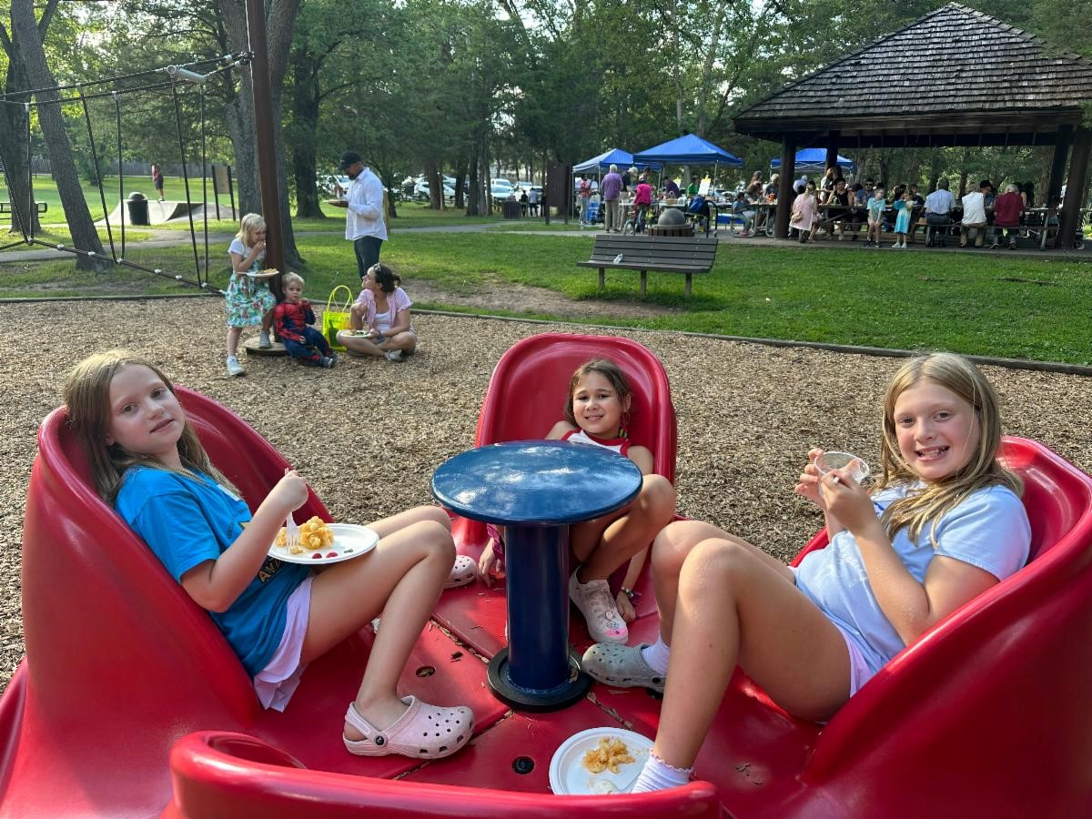
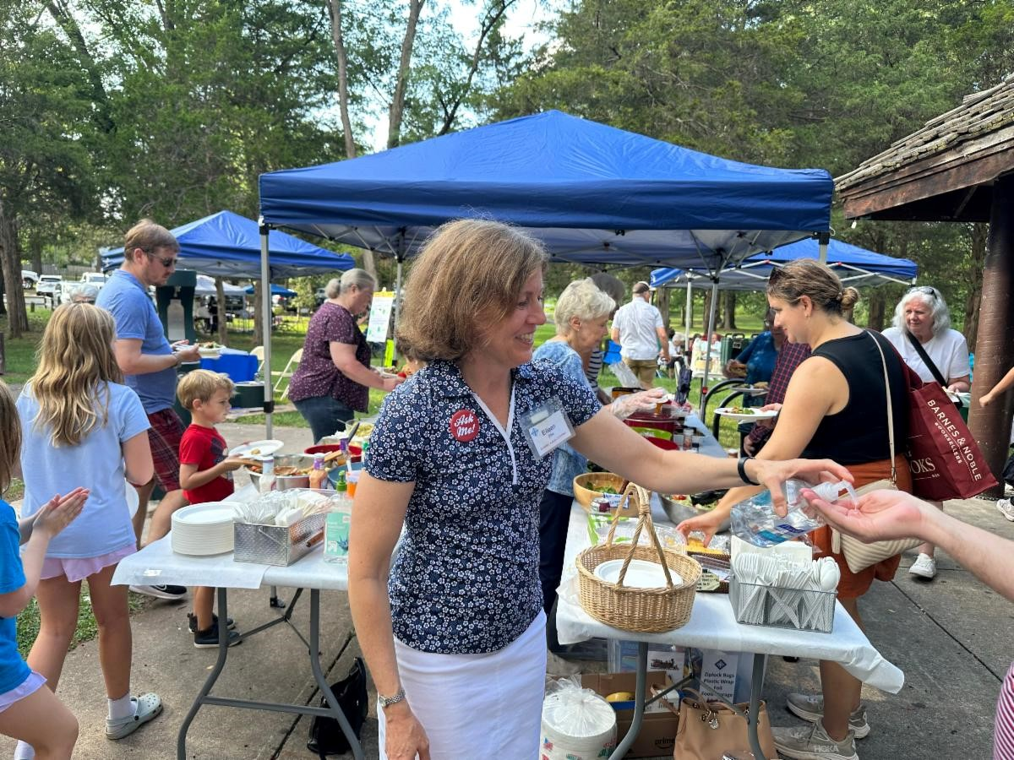
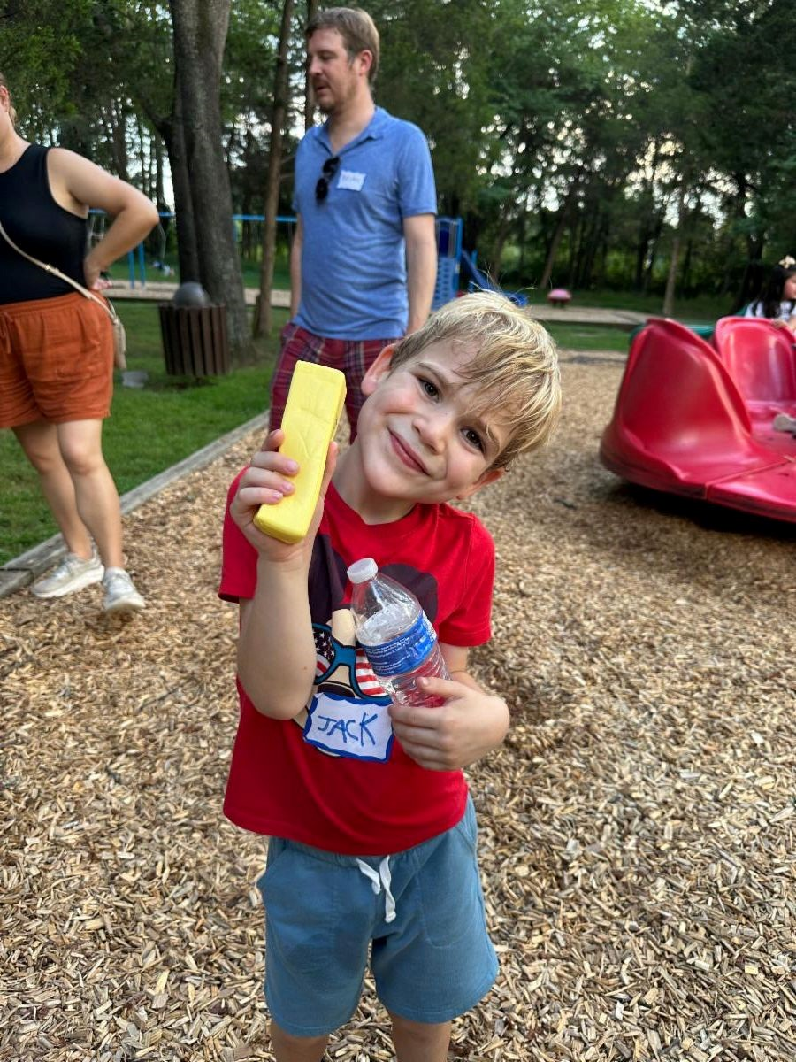
To see the whole newsletter in your browser
click her
e
Access Our Website for Worship Link
s
Fun was had by all at last Sunday's Fall Fellowship!
THANKS to everyone who helped make the event a
success!
Egg-cellent News for the Food Pantry!
Thanks to a very generous donation to the food pantry, we have 150 dozen eggs ready to
share with the community at today's pantry distribution day!


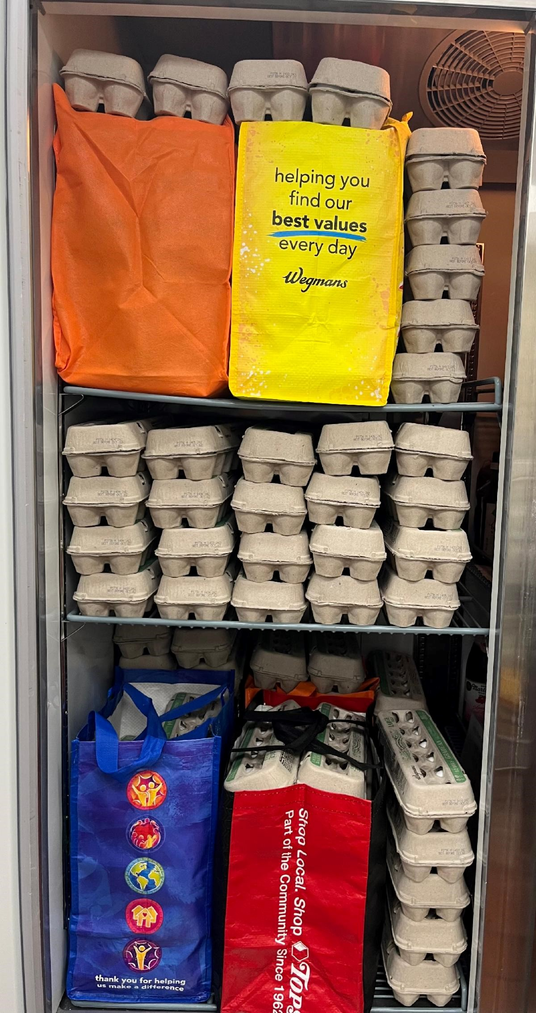
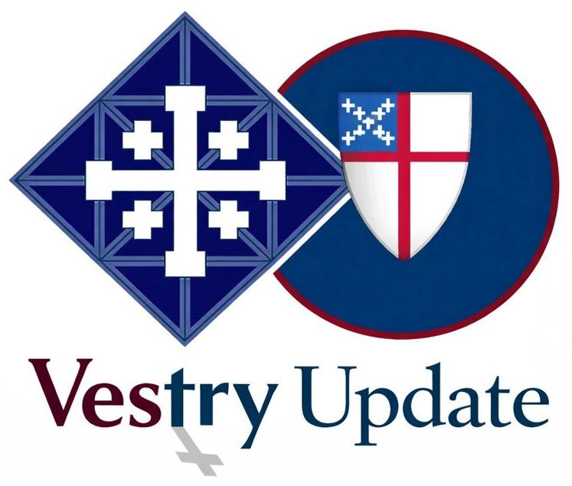
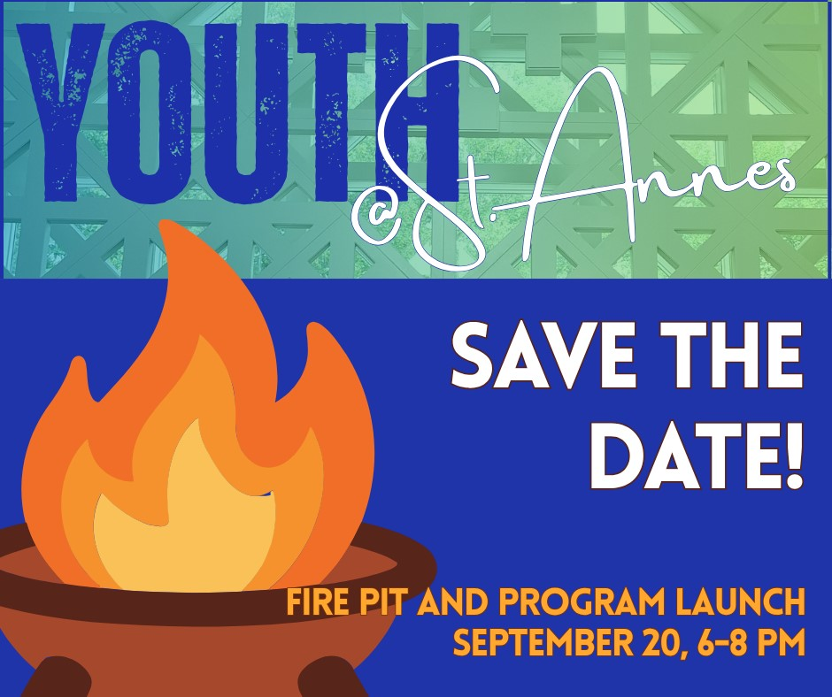
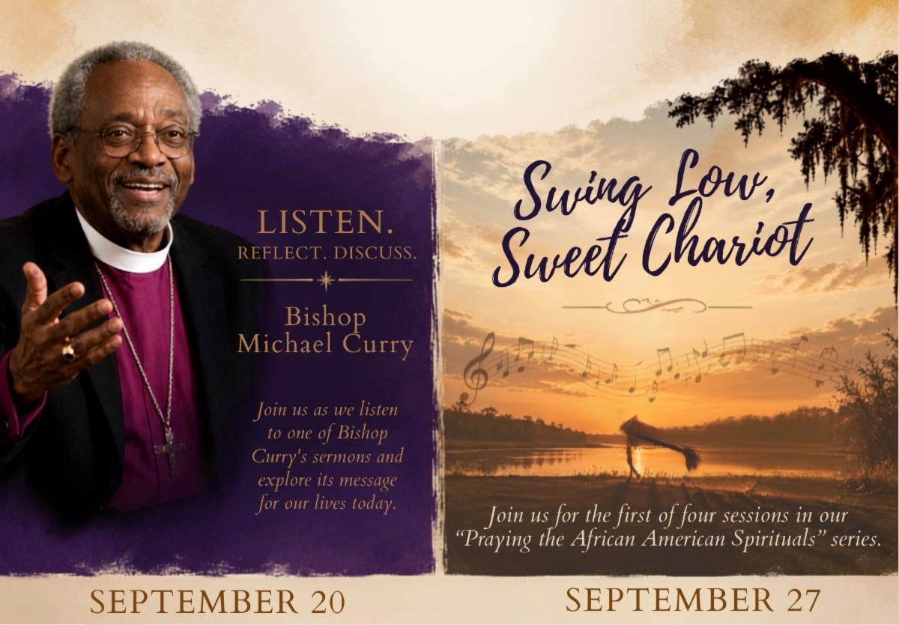
We are so appreciative of the many pantry donations given
by
our
congregation.

Usually,
purchasing
eggs
is
not
in
our
budget but thanks to an amazing donation, this is our second
month
of
eggs
and
we
should
be
able
to
have
these
highly
requested items for the rest of the year!

Vestry Corner
Vestry met last weekend for a special update on the status
of
our
capital
campaign.
The
Capital
Campaign
Committee
shared
the
work
they’ve
been
doing
throughout
the
summer
and
presented
a
proposed
path
forward.
Vestry
approved
the
committee’s
proposed
vision
and
asked them to share the update with the congregation this
Sunday,
September
20
.
We
look
forward
to
sharing
more
about
the
vision,
the
work
ahead, and how our entire congregation can be part of this exciting next chapter.
Youth Fire Pit & Program Year Launch
This Sunday, September 20, 6:00-8:00 PM, St. Anne's
Parking Lot
All youth between 6th and 12th grade are invited to bring
their parents to our
Fire Pit and Program Year Launch
for youth ministry at St. Anne's!
Come meet our leadership team, find out about service
projects
and
gatherings
we
already
have
planned,
and
make
your
voice
heard
as
we
brainstorm
the
schedule
for
the
rest
of
the
year!
We'll
provide
food
and
(
not
just
stuff
for
S'Mores),
and
plenty
of
time
to
reconnect
with
St.
Anne's friends.

If someone in your family is interested in youth ministry at St. Anne's, please
r
re
g
iste
a
them for the current
p
ro
g
ram
y
e
r
!
Adult Formation
This Sunday, September 20, 4:00-5:30 PM, Library
Sunday, September 27, 4:00-5:30 PM, Library
Sunday, October 11, 4:00-5:30 PM, Library
Mark
your
calendars
for
the
first
three
of
many
fabulous adult formation opportunities coming this
fall!
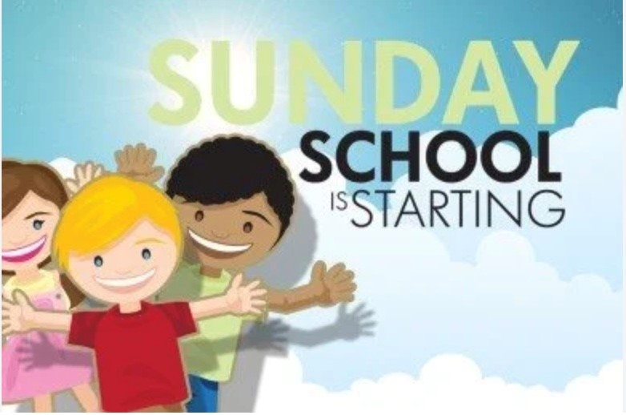
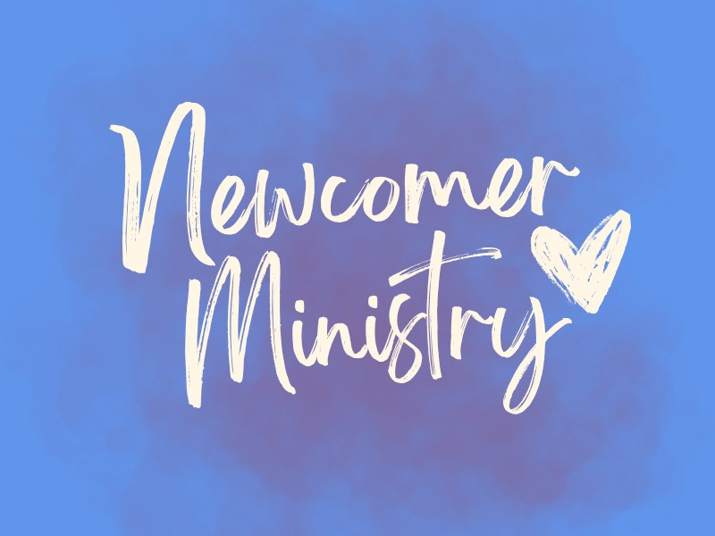
This

Sunday, September 20, 4:00–5:30 PM
Join us as we listen to a contemporary, influential sermon from former Presiding Bishop
Michael Curry and explore how its message speaks to our own ministry.
Sunday, September 27, 4:00–5:30 PM
We’ll begin the first of four sessions in our
Praying with the African American Spirituals
series.
We're thrilled to kick off the series with
Swing Low, Sweet Chariot
, an African
American Spiritual and well known Christian hymn on September 27.
We’re so excited to continue this popular series for a fourth year, with two sessions this
fall and two more in the spring. You can expect opportunities to engage with our country’s
history and faith through music while expanding and deepening our racial justice ministry.
Sunday, October 11, 4:00–5:30 PM
We’ll begin the first of four sessions in our "
Living Faithfully with Alzheimer's Series
" on
October
11
.
Featuring
former
Assistant
Bishop
of
Virginia,
Porter
Taylor,
explore
the
spiritual journey of living with Alzheimer's through the lens of faith, loss, and gratitude.
Questions? Please
reach out to Chris Cameron
.
To
see
an
entire
schedule
of
our Adult
Formation
Fall
offerings,
clic
k
her
e
.
2026-27
Sunday School & Youth Group
Re
g
ister Her
e
!
Parents,
please
take
a
moment
to
register
your
child(ren)
for
Sunday
School
Pre-K–6th
(
grade)
or
Youth Group (6th–12th grades) if you haven't already
done
so.
We
ask
all
families
to
complete
a
new
registration each year, even if you’ve registered in the
past.
Click here to re
g
iste
r
. We look forward to a joyful year of faith, learning, and community!
We Still Need Greeters for our
Newcomer Ministry...Don't be Shy,
Si
g
n
U
p
Toda
y
!
St. Anne’s is known for its warm and welcoming spirit,
and as we reinvigorate our Newcomer Ministry, we’d
love to build on that tradition of hospitality.
We are looking for volunteers at each service to serve
as a designated Newcomer Greeter. The role is simple: after the service, spend a little
time chatting with people who are new to St. Anne’s or visiting for the first time and would
like
to
learn
more
about
our
church.
We’ll
provide
some
helpful
guidelines
and
suggestions for how to engage with newcomers and make them feel especially welcome.
Our hope is to have enough volunteers that each person would only need to serve once
every six weeks or so, making this an easy and meaningful way to help St. Anne’s live out
its welcoming spirit.
If you’re interested in volunteering, please
click here to si
g
n u
p
for one (or more!) slots.
Please reach out to
Daria Antonucci
or
Nanc
y
Santoro
with any questions.
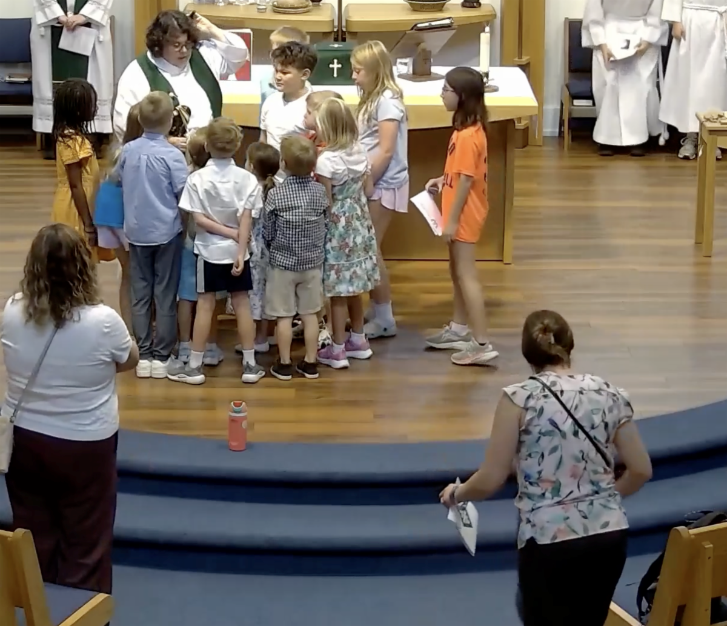
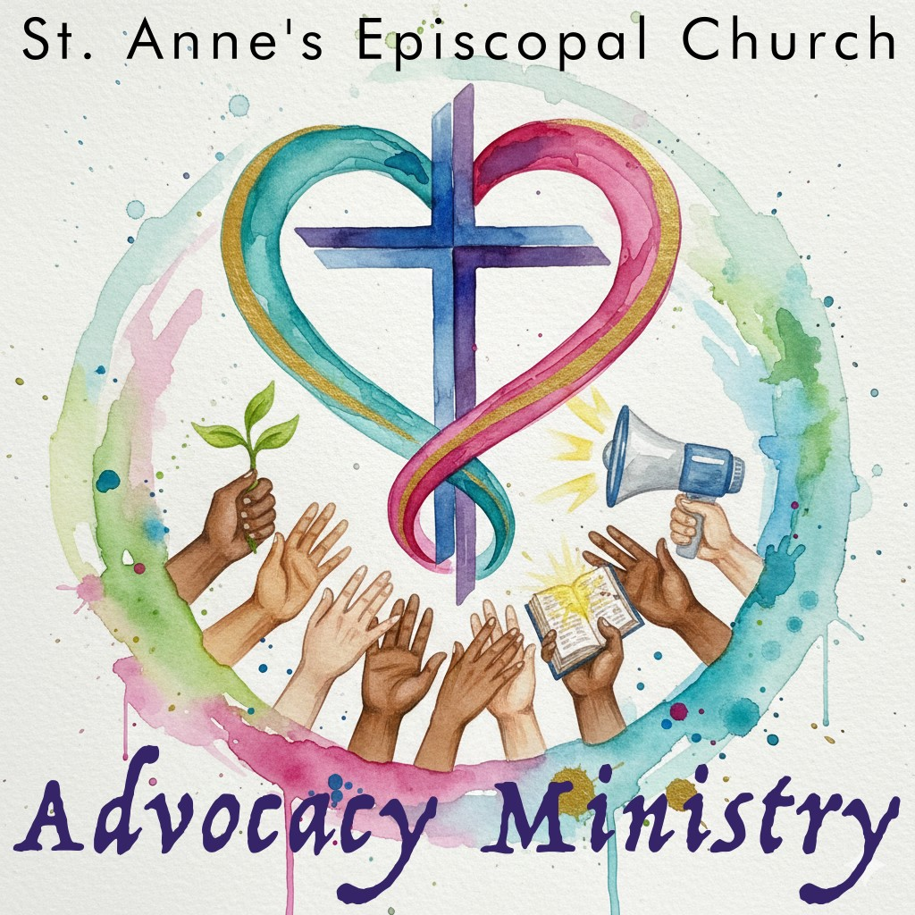

Thank you for helping us make sure everyone who walks through our doors feels truly
welcomed and at home at St. Anne’s!
Kids Key Moment
This week our classes celebrated the beginning of Sunday
school by telling the story of the beginning of us. Our older
classes painted creation scenes on rocks and talked about
rest.
Our
Godly
Play
class
enjoyed
playing
shepherd
together, and our youngest class created special balloons.
And
then
we
got
to
hear
a
sound
that
we
missed
all
summer--the children bidding the peace!
Arlington Interfaith Vigil Against ICE
Cruelty
This Saturday, September 19, vigil and optional procession
Alcova Heights Park, 2:00-4:00 PM
This interfaith public ritual will lift up the memory of those
whose lives have been taken unjustly by our own country, a
matter of sorrow and shame, and of supreme importance to
call out in this national emergency.

Together we will honor the over 50 people who have died by the hands of ICE or in ICE
custody since 2025 along with the 15K+ people taken in by ICE in Virginia, 76% having no
criminal record.
We
will
gather
to
hear
from
faith
voices
proclaiming
the
importance
of
justice
and
welcome, and we will remember the names of those we have lost. An optional procession
will then go through the neighborhood carrying signs with the names and faces of those
who have died. Signs will be provided. Come to join in community and act in public for
what is right.
Vote Faithfully
Early
in
person
voting
for
the
November
3

election
begins
tomorrow,
Friday,
September
18.

Visit
your
county
Office

of
Elections
website
for
locations
and
hours
and
to
review
a
sample ballot.
Virginians will elect a senator and members of the House of
Representatives and vote on three proposed amendments to
the state constitution.

Some jurisdictions will also vote on local offices and issues.
Mailing of absentee ballots will also begin September 18.

If you plan to vote by mail, be
sure
to
request
your
ballot
now
and
complete
and
return
it
promptly
.

You
can
request
your
ballot
online
from
your
county

Office
of
Elections
website
on
the
state
Department of Elections website at
elections.Vir
g
inia.
g
o
v
.
Absentee
ballots
may
be
returned
by
mail
or
in
secure
drop
boxes
or
handed
in
at
early

voting locations.

If you plan to mail your ballot,

be

sure to allow enough time for it to
be delivered by the deadline on Election Day.

You may also want to consider taking your
ballot to a post office and asking for a hand stamp.
Any questions about voting and registration can be directed to
Carol Hurlburt
.

Volunteer with The Closet
Try something new! Volunteer with The Closet,
a
well-run
thrift
store
that
gives
back
to
the
community
in
countless
ways.
Its
success
depends
on
dedicated
volunteers,
and
every
helping hand is truly valued.
Volunteer Dates Assi
g
ned to St. Anne's
:
This Saturday, September 19
Tuesday, October 13
Thursday, November 5
Tuesday, December 1
Saturday, December 26
They
will
also
be
needing
extra
support
from
the
volunteers
the
week
of
October
12
,
getting things unpacked, priced, and put on display tables at the Moose Lodge for the
Everything Christmas Sale on October 16-17. Everyone really enjoys helping with this
event.

If you and/or a friend might be interested in volunteering, please give it a try! You won't
regret it!
Please feel free to
reach out to Rita Smith
if you have any questions or would
like to join the fun!
p
Other U
comin
g
Closet Dates to Save
:
October 16–17: Everything Christmas Sale
December 12: Winter Market
Everything

Christmas

is Coming!

The Closet’s 2026 Everything Christmas event is in mid-October. Sales dates are
3-7
PM Friday, October 16, and 9:00 AM-12:00 PM on Saturday, October 17, at the
Herndon Moose Lodge, 779 Center Street in Herndon.

The Closet needs volunteers the entire week leading up to and including the sales
dates and cleanup afterwards. High school students in particular are needed on
October
10

to
transfer
500+

donation
bins
to
the
Moose
Lodge
and
for
the
cleanup. Next will come the unpacking of the bins on Sunday afternoon and then
checking, pricing and displaying merchandise Monday-Thursday.

We
welcome
high
school
students
as
their
school
schedules
permit
(
happy
to
confirm volunteer hours) and adults throughout the week, starting on Sunday, Oct.
11
, and continuing through to the actual sale and cleanup. This will be our October
youth @ St. Anne's service event.
All volunteering is at the Moose Lodge, 779 Center Street, Herndon.

Click here to si
g
n u
p
.

Seen Around St. Anne's
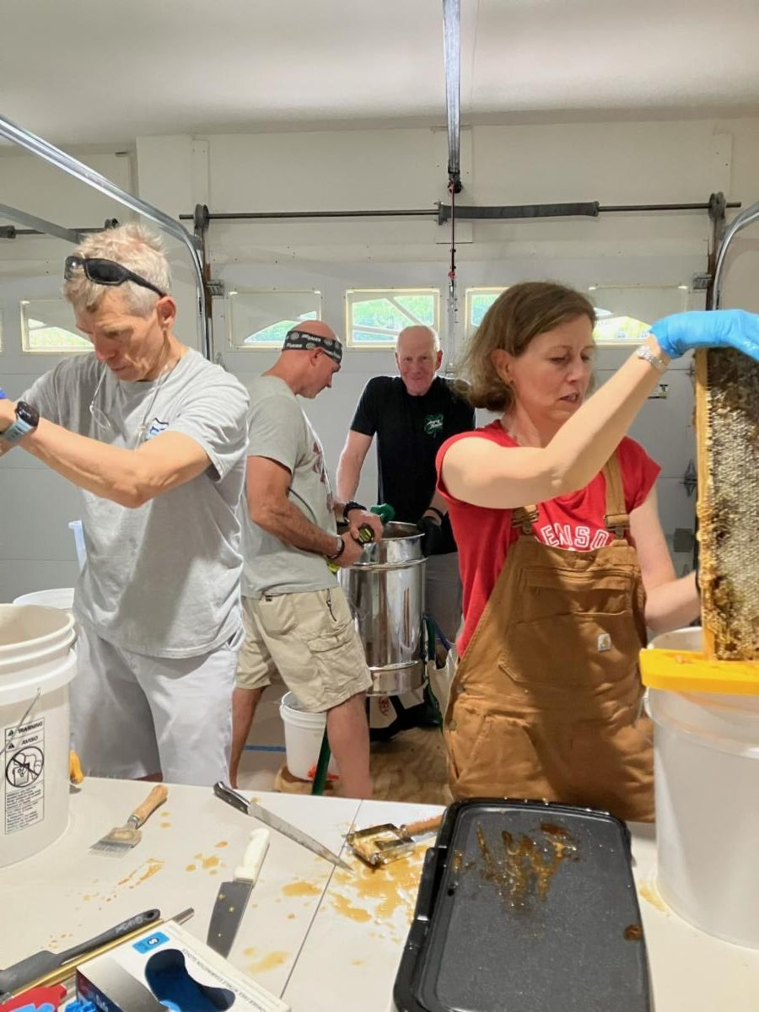
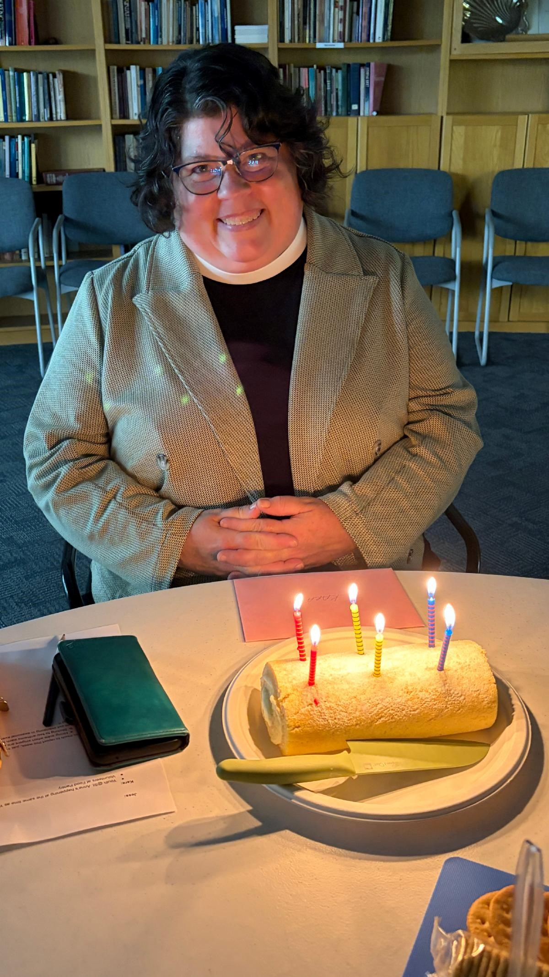
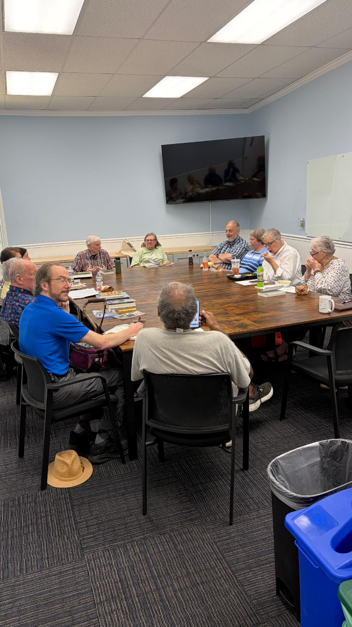
Last Saturday, the St. Anne’s
Bee Team extracted the July
-
Sept honey in Nancy
Santoro’s garage. The hard-
working team included Brett
Knudson, Ray Lundquist,
Joe
Giaquinto
, Donna
Vandegrift, Nancy Santoro,
and Eileen Ellis. Eileen said
that with more hands and
the electric drill on the
extractor, they were done in
2.5
hours
!
The staff celebrated Mtr
Kara's birthday on
Wednesday. Please be sure
to wish her a happy birthday
when you see her!
The St. Anne's Book Club
met on Monday for lunch
and interesting discussion.
St. Anne's Vestry
Daria Antonucci, Sarah Brummett, Bernadette Capelle, Marian Egge, Rosie Horn (Jr Warden), Brandon Huffman,
Margaret Light (Sr Warden), Christian Pelfrey, Suzanne Robinson, Nancy Santoro, Matt Scott, The Very Rev.
Jessica Holthus (Rector & Chair), The Rev. Kara Laughlin (Associate Rector for Discipleship)
Contact Us
The Ver
y
Reverend Jessica Holthus
, Rector
The Reverend Kara Lau
g
hlin
, Associate Rector for Discipleship
Robert Hamilton
, Music Director
Mar
g
aret Li
g
ht
, Senior Warden
Sheri Schaffer
, Parish Administrator
An
g
ie Gray
, Office Administrator
Our offices are open Monday through Friday from 9:00 am to 3:00 pm. We are available by
phone and email at other times. We check the office voicemail at (703) 437-6530 regularly.
Have an announcement? Need to reserve space?
The
deadline
to
submit
an
announcement
for
enews
is
12:00

pm
on
Tuesdays
.
Email it to Sheri
.
In addition to the text of your announcement, include graphics, photos
and links in your email.
To
reserve space at St. Anne's for an upcoming meeting/event,

email Sheri
with the
date, time and number of people you expect in attendance.




Was this newsletter forwarded to you?
Sign Up For Enews
!
St. Anne's Episcopal Church, Reston |
1700
Wainwright Drive
|
Reston, VA 20190-5500 US
Unsubscribe
|
Update Profile
|
Constant Contact Data Notic
e

