
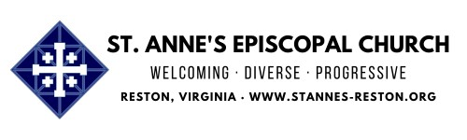
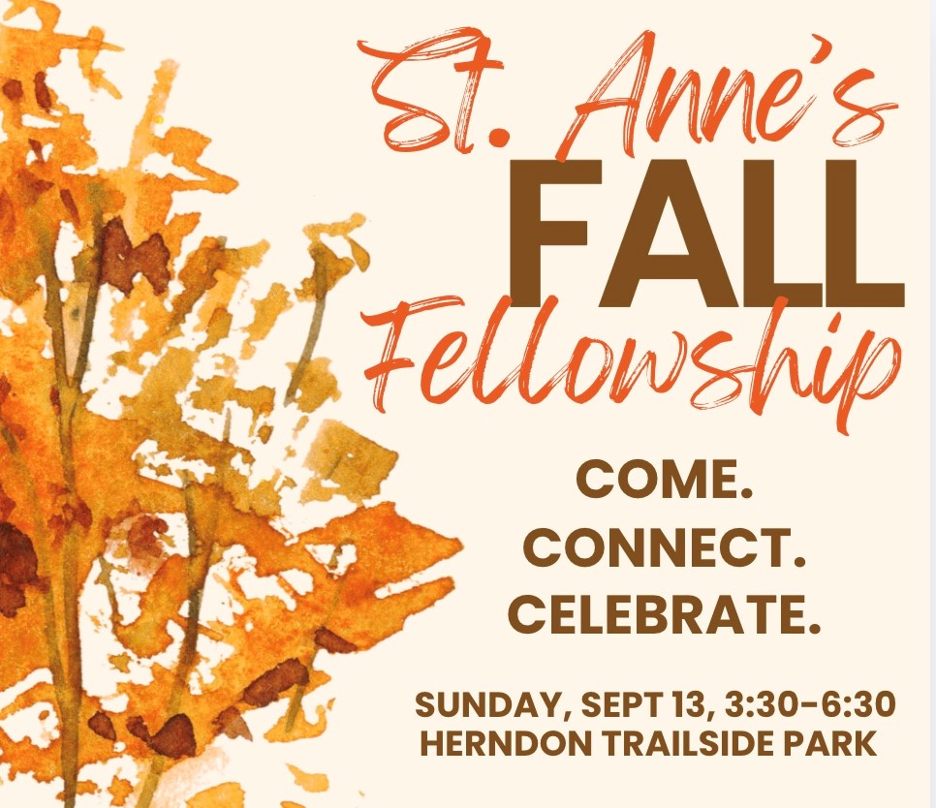
To see the whole newsletter in your browser
click her
e
Access Our Website for Worship Link
s
Get Excited!
Fall Fellowship is This Sunday!
--------------------->

SIGN UP TODA
Y

<---------------------
Sunday, September 13, 3:30-6:30 PM, Herndon Trailside Shelter, 1022 Crestview
Drive
It's
not
too
late
to
plan
to
join
us
for
our
congregation-wide
Fall
Fellowship
at
Herndon Trailside Shelter this Sunday, September 13 from 3:30-6:30 PM.
This event kicks off our exciting program year in the spirit of "Community!" And
what a fabulous community we have! There will be food, fellowship, games, music
and prayers.
Si
g
n u
p
her
e

to bring a side dish or dessert or volunteer to help with parking, set
up and/or clean up.
See map below for location and parking information (courtesy of Chris Korbuly).
You can click on it and download it. We also have copies available at church for
you.
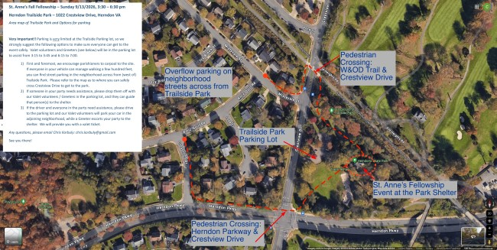
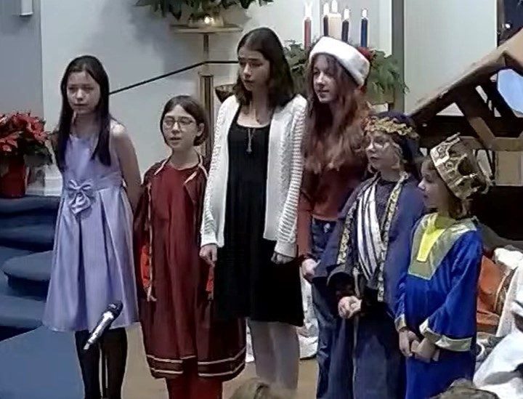
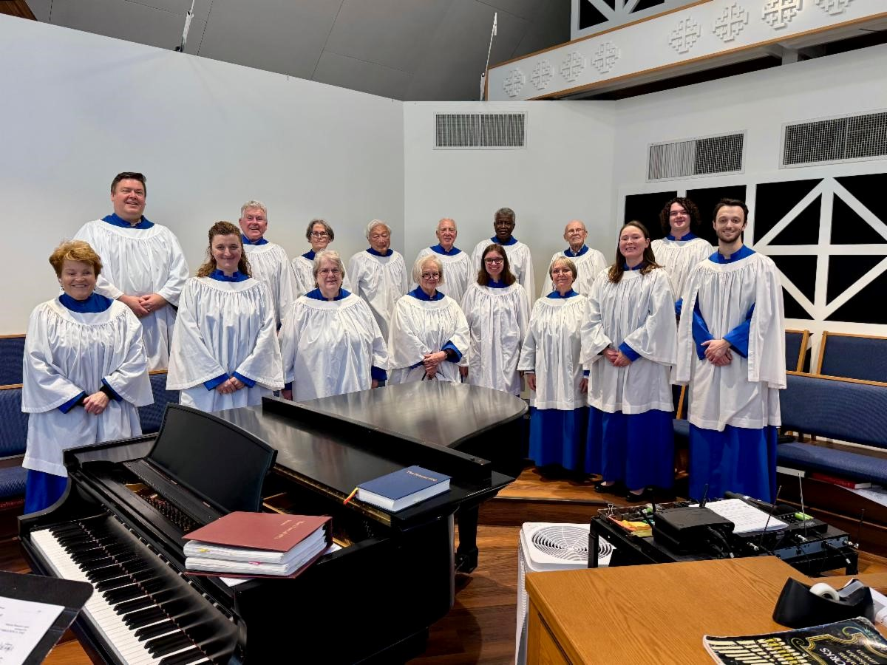
ALL GOD'S CHILDREN HAVE A PLACE IN THE CHOIR!
St.
Anne’s
Choristers
is
welcoming new members for the
upcoming
church
year!
All
children
and
youth
in
Grade
3
and up are invited to join.
Rehearsals
Sundays after the
:
10:00
45
AM service (approx.
minutes).
Singing in Church
About once a
:
month.
First Rehearsal
THIS SUNDAY,
:
September 13. No prior
experience needed...just a love
for music and a willingness to
participate!
How to Join?
If your child is
interested, please speak to Rob
after a service or
email him
.
St.
Anne’s
Choir
is
always
looking for new voices to join our
musical
ministry,
whether
you're
a soprano, alto, tenor, or bass!
As
we
prepare
for
the
new
program year, now is the perfect
time
to
get
involved.
Rehearsals
are
held
on
Wednesdays
from

7:00
to

9:00
PM,
and
Sunday
mornings
at
9:00

AM
before
the
service.
If
you're
interested
in
joining
or
would
like
more
information,
please
speak
with
Rob
after
a
service
or
reach
out
to
him
via
email
.

2026-27
Sunday School & Youth Group
Re
g
istration Now O
p
e
n
!

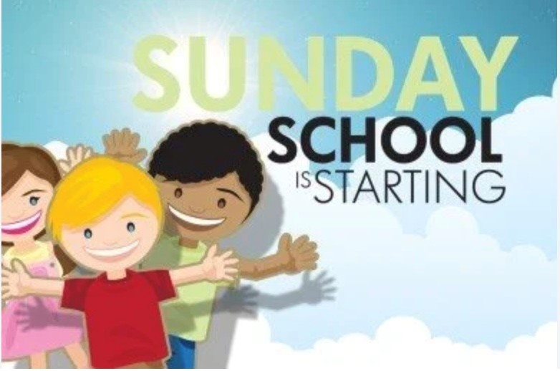
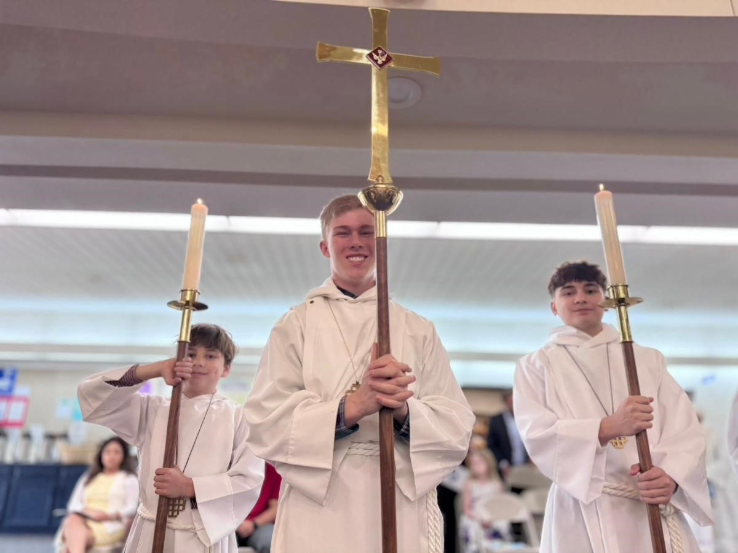
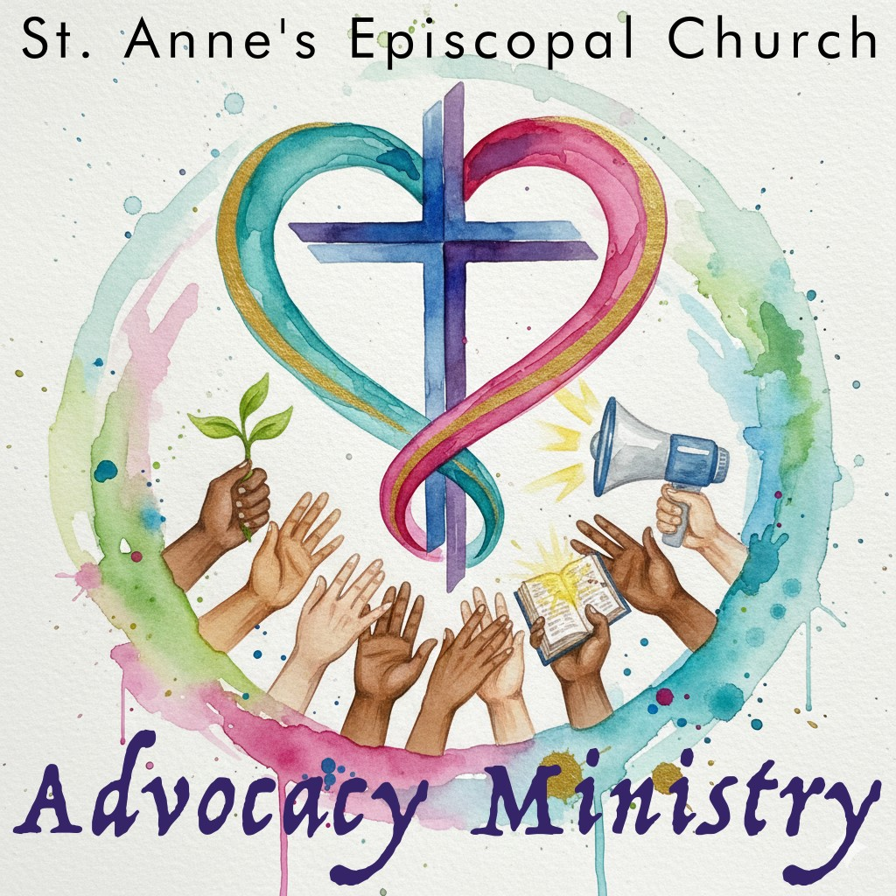
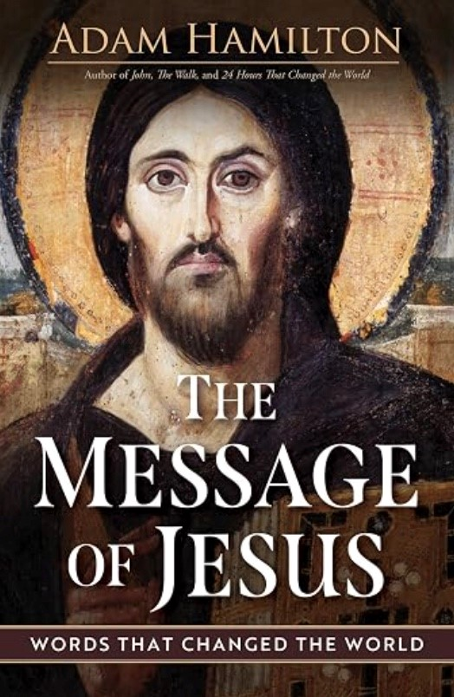
We are so excited to begin our new program year on
September
13
th!
Parents,
please
take
a
moment
to
register your child(ren) for Sunday School (Pre-K–6th
grade) or Youth Group (6th–12th grades). We ask all
families to complete a new registration each year, even
if you’ve registered in the past.
Click here to re
g
iste
r
.
We look forward to a joyful year
of faith, learning, and community!
Acolyte Training
This Sunday, September 13, following the 10 AM
service
We
will
be
hosting
an
Acolyte
Training
session
on
Sunday, September 13, immediately following the 10:00
AM service.
This
training
session
is
for
both
current
acolytes
and
prospective acolytes who are interested in serving in this important ministry. The session
will cover the responsibilities of an acolyte, the order of service, and practical instruction
for serving during worship.
If you are interested in becoming an acolyte please email
er
Seward Coo
p

and
Mother
Kara
.
We look forward to seeing you there!
Advocacy Ministry Meeting
This Sunday, September 13, after 10 AM service, Library
Please
join
us
on
Sept
13

after
the
10
am
service
in
the
Library as we gather to reflect on work done and what we
want to accomplish for Fall & Winter 2026.

If you are not yet on the Advocacy Ministry email list please
let Susan know
and we will get you added.
Hope to see you there!
Monday Morning Bible Study
This Monday, September 14, 10:30-12:00 via Zoom
The Monday Morning Bible Study will resume on Monday, Sept. 14,
via Zoom, 10:30 a.m. - 12:00 p.m.

We will begin the semester with
The Message of Jesus
by Adam
Hamilton (one of our favorite authors).

Class
format
is
a
brief
video
by
the
author
followed
by
class
discussion.

The book is available on Cokesbury and Amazon.
To join the fun
contact Jane Smith
.

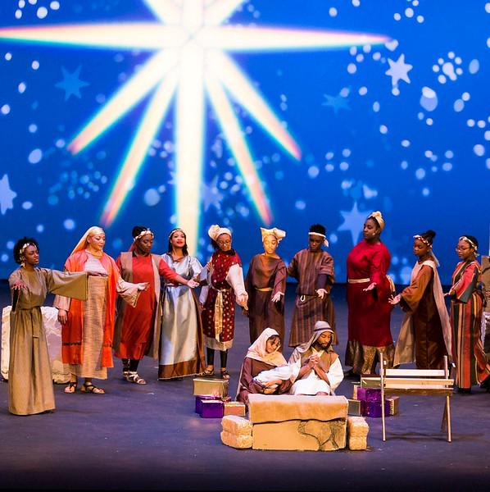
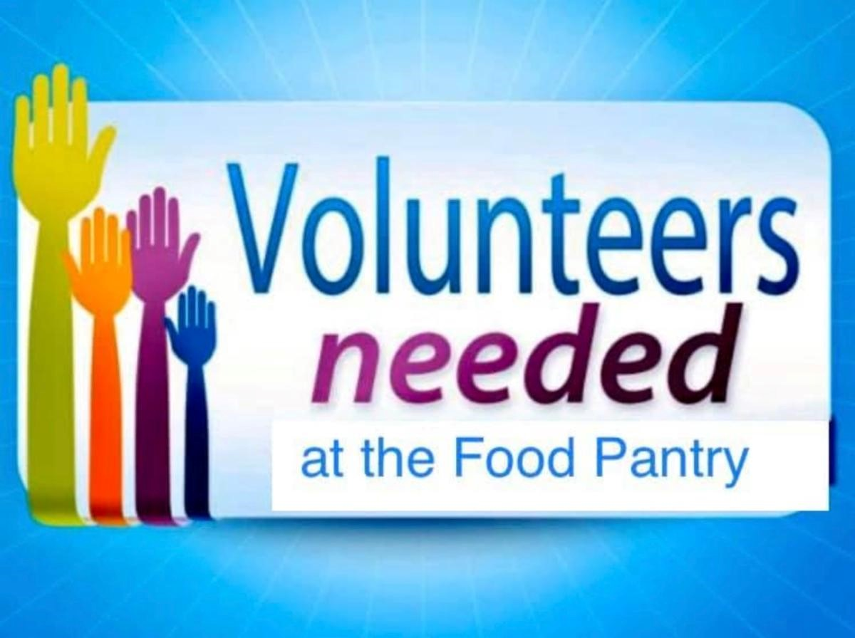
St. Anne's Book Club (In Person!)
This Monday, September 14, 12:00 PM, Room 6
Bring your own lunch!
Join us for an in-person book discussion of
The Coming Wave
by
Mustafa
Suleyman
on
Monday,
September
14
,
in
Room

6
at
St.
Anne's. Bring your own lunch.
A
co-founder
of
DeepMind,
Suleyman
explores
how
artificial
intelligence and other rapidly advancing technologies are poised to
transform our world, bringing extraordinary opportunities as well as
profound challenges. Together, we'll discuss what this technological
wave could mean for our future and how society might navigate the road ahead.
Whether
you've
read
every
page
or
just
want
to
join
the
conversation,
all
are
welcome!

Any questions,
reach out to Don Boileau
.
Black Nativity by Langston Hughes: Save
the Date &
Si
g
n U
p
Toda
y
!
Friday, December 4, 6:30 PM, bus departs St. Anne's
Production at George Mason University's Hylton Theater
Sign-up deadline is October 9
This
Advent
Season
enjoy
Langston
Hughes'
joyous
musical
Black Nativity
with St. Annes on Friday, December
!
4
at George Mason University's Hylton theater
First
performed
in
1961
,
this
powerful
work
blends
scripture
with
gospel,
blues,
and
spirituals, creating a vibrant expression of faith, joy, and community.

This professional
touring company performance of
Black Nativity
completely sold out in 2025.

We were able to reserve a block of 40 tickets and coach bus transportation for $55 per
person. The bus departs the church parking lot at 6:30 PM on Dec. 4.
Click here to si
g
n u
p
and pay.

Note
that
we
don't
want
financial
considerations
to
prevent
anyone
from
participating.
Please contact
Mtr Kara
if you need financial assistance. You can still register - simply
choose the appropriate option from the drop-down menu in the sign-up form.
Deadline to sign up is October 9
but don't wait because this is a popular event and will
likely sell out.
Please contact
Lorraine Cross
with any questions.
Food Pantry Volunteers Needed
Next Thursday, September 17, 10:00 AM–1:30 PM
The St. Anne’s Food Pantry is urgently looking for
volunteers to help with our Thursday, September 17
food distribution.
This
important
monthly
event
requires
30

volunteers,
and we currently have only 18 people signed up. That
means we’re still looking for 12 more volunteers to make the day a success!
There are a variety of ways you can help, including:
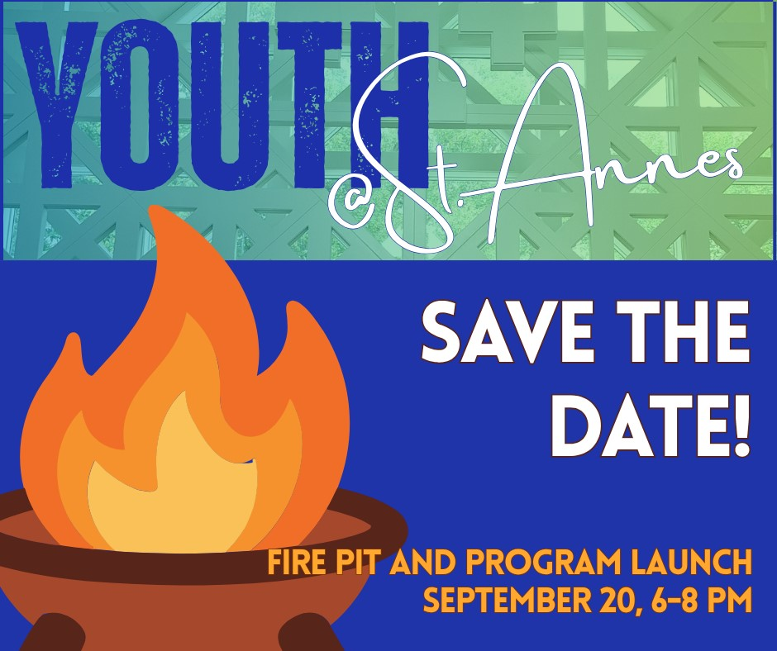
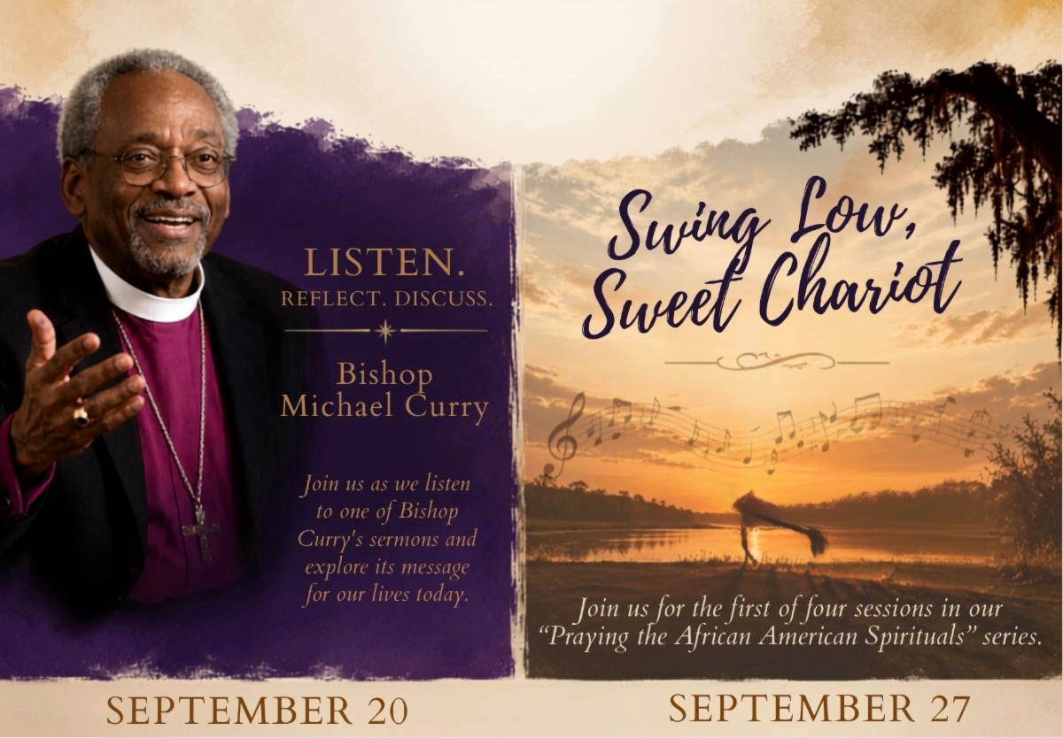
Distributing food to our neighbors
Assisting with grocery carts
Helping guests navigate the pantry
Serving as a door monitor for those accessing the restrooms
Other tasks that help keep the distribution running smoothly
No
special
experience
is
needed...
just
a
willingness
to
lend
a
hand
and
help
our
community!
If you’re able to volunteer, please sign up here:
Si
g
n u
p
to voluntee
r
Or, if you prefer, email Food Pantry Manager Glen Corso at
stuartcrest
@g
mail.com
.
Every volunteer makes a difference. Thank you for helping St. Anne’s continue to serve
our neighbors!
Youth Launch Save the Date
Sunday, September 20, 6:00-8:00 PM, St. Anne's Parking
Lot
All youth between 6th and 12th grade are invited to bring
their parents to our
Fire Pit and Program Year Launch
for youth ministry at St. Anne's!
Come meet our leadership team, find out about service
projects
and
gatherings
we
already
have
planned,
and
make
your
voice
heard
as
we
brainstorm
the
schedule
for
the
rest
of
the
year!
We'll
provide
food
and
(
not
just
stuff
for
S'Mores),
and
plenty
of
time
to
reconnect
with
St.
Anne's friends.

If someone in your family is interested in youth ministry at St. Anne's, please
re
g
iste
r
a
them for the current
p
ro
g
ram
y
e
!
r
Adult Formation
Sunday, September 20, 4:00-5:30 PM, Library
Sunday, September 27, 4:00-5:30 PM, Library
Mark
your
calendars
for
the
first
two
of
many
fabulous adult formation opportunities coming this
fall!
First up
:

Sunday, September 20, 4:00–5:30 PM
Join us as we listen to a contemporary, influential
sermon from former Presiding Bishop Michael Curry and explore how its message speaks
to our own ministry.
Next up
:

Sunday, September 27, 4:00–5:30 PM
We’ll begin the first of four sessions in our
Praying with the African American Spirituals
series.
We're thrilled to kick off the series with
Swing Low, Sweet Chariot
, an African
American Spiritual and well known Christian hymn on September 27.
We’re so excited to continue this popular series for a fourth year, with two sessions this
fall and two more in the spring. You can expect opportunities to engage with our country’s
history and faith through music while expanding and deepening our racial justice ministry.
Questions about either offering? Please
reach out to Chris Cameron
.
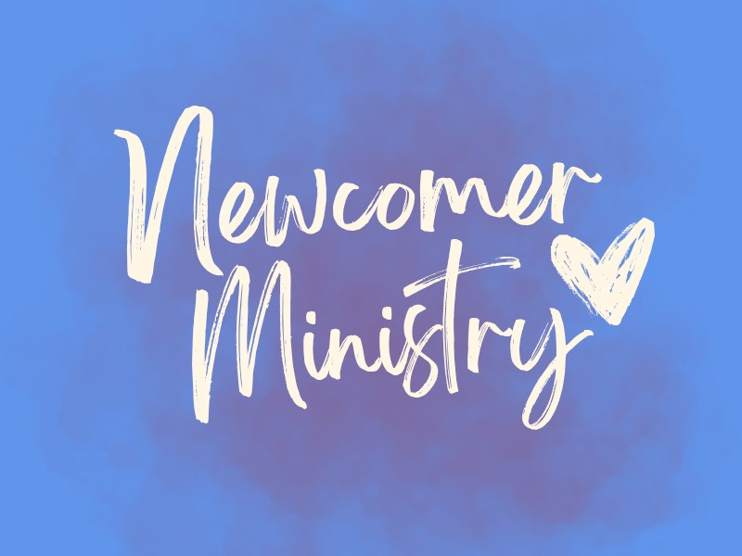

Help Us Welcome Our Newcomers
p
Click here to si
g
n u
St. Anne’s is known for its warm and welcoming spirit,
and as we reinvigorate our Newcomer Ministry, we’d
love to build on that tradition of hospitality.
We are looking for volunteers at each service to serve
as
a
designated
Newcomer
Greeter.
The
role
is
simple: after the service, spend a little time chatting
with people who are new to St. Anne’s or visiting for the first time and would like to learn
more about our church. We’ll provide some helpful guidelines and suggestions for how to
engage with newcomers and make them feel especially welcome.
Our hope is to have enough volunteers that each person would only need to serve once
every six weeks or so, making this an easy and meaningful way to help St. Anne’s live out
its welcoming spirit.
If you’re interested in volunteering, please
click here to si
g
n u
p
for one (or more!) slots.
Please reach out to
Daria Antonucci
or
Nanc
y
Santoro
with any questions.
Thank you for helping us make sure everyone who walks through our doors feels truly
welcomed and at home at St. Anne’s!
Arlington Interfaith Vigil against ICE cruelty
Saturday,
September
19
,
vigil
and
optional
procession
Alcova Heights Park - 2:00-4:00 PM
This interfaith public ritual will lift up the memory of those
whose lives have been taken unjustly by our own country, a
matter of sorrow and shame, and of supreme importance to
call out in this national emergency.
Together we will honor the over 50 people who have died by
the hands of ICE or in ICE custody since 2025 along with
the 15K+ people taken in by ICE in Virginia, 76% having no criminal record.
We
will
gather
to
hear
from
faith
voices
proclaiming
the
importance
of
justice
and
welcome, and we will remember the names of those we have lost. An optional procession
will then go through the neighborhood carrying signs with the names and faces of those
who have died. Signs will be provided. Come to join in community and act in public for
what is right.
Diaper Ministry
Our next pantry distribution is Thursday, September 17, and
we’re especially in need of diapers in sizes 4, 5, and 6, with
a special focus on size 6. We’re also grateful for donations
of baby wipes.
If you’re doing some fall housecleaning, please keep us in
mind! Gently used toys and stuffed animals are always welcome and can bring a little
extra joy to the young children who come through our pantry.



Thank
you,
as
always,
for
your
incredible
generosity
and
tireless
support.
We
are
so
grateful for everything you do to help our families.
Passport to Fun
Congratulations to every child who journeyed with Jesus this
summer! We made chalk footprints and packed backpacks in
summer
chapel.
We
filled
out
Passports
and
learned
a
little
more about the church service. And now it's time to celebrate!
We
hope
our
passport
participants
will
join
us
at
our
fall
fellowship
gathering,
where
we
will
give
out
prizes
to
our
participants. Hope to see you there! And we hope you'll join us
for Sunday School this Sunday where the journey continues!
Vote Faithfully
On November 3, Virginians will elect a senator and members of
the
House
of
Representatives
and
vote
on
three
proposed
amendments to the Virginia Constitution.

Some jurisdictions will
also elect local officials and vote on local issues.
Important dates:
September 18:

Early in person voting begins.
October 23:

Deadline to register or update your registration and request a ballot by
mail.
You can register or update your registration online and get other election information by
visiting the Virginia Department of Elections website at
elections.vir
g
inia.
g
o
v
.

The website invites registered voters in Virginia to “Become an Officer of Elections and
lend a hand for democracy “ by volunteering to work at the polls.

Full details for each county are available on the county’s Online of Elections website.
Some counties, including Fairfax and Loudon, offer opportunities for high school students
to volunteer as pages at the polls on Election Day.
Any questions about voting and registration can be directed to
Carol Hurlburt
.
Volunteer with The Closet
Try something new! Volunteer with The Closet,
a
well-run
thrift
store
that
gives
back
to
the
community
in
countless
ways.
Its
success
depends
on
dedicated
volunteers,
and
every
helping hand is truly valued.
g
ned to St. Anne's
Volunteer Dates Assi
:
Saturday, September 19
Tuesday, October 13
Thursday, November 5
Tuesday, December 1
Saturday, December 26
They
will
also
be
needing
extra
support
from
the
volunteers
the
week
of
October
12
,
getting things unpacked, priced, and put on display tables at the Moose Lodge for the
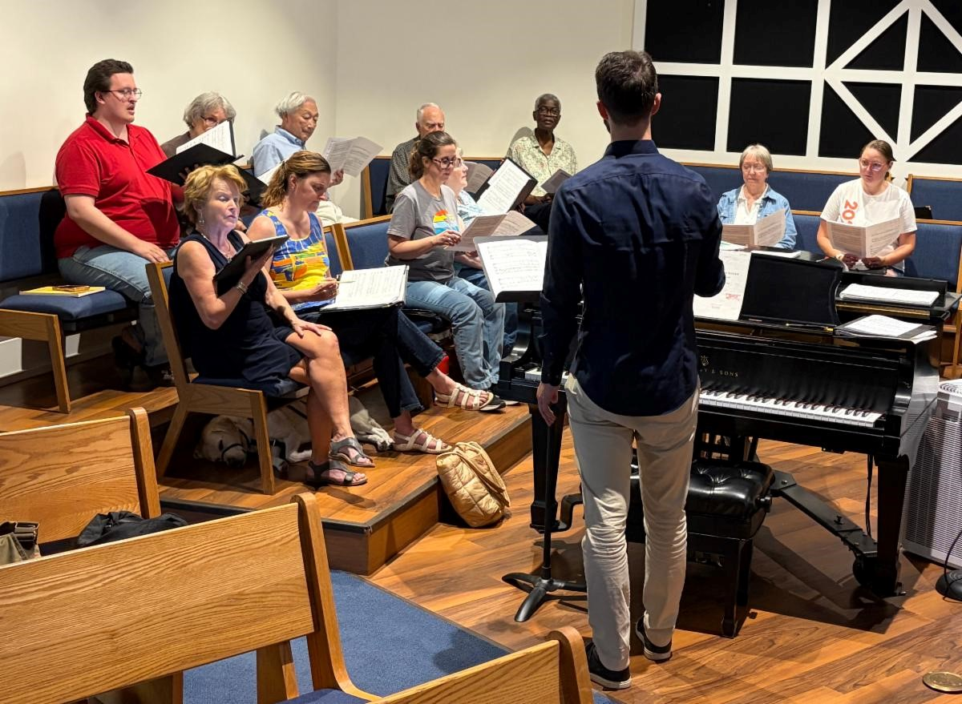
Everything Christmas Sale on October 16-17. Everyone really enjoys helping with this
event.

If you and/or a friend might be interested in volunteering, please give it a try! You won't
regret it!
Please feel free to
reach out to Rita Smith
if you have any questions or would
like to join the fun!
p
Other U
comin
g
Closet Dates to Save
:
September 5: The Closet's Annual Fashion Show (Get your ticket ASAP because
they usually sell out.)
October 16–17: Everything Christmas Sale
December 12: Winter Market
Everything

Christmas

is Coming!

The Closet’s 2026 Everything Christmas event is in mid-October. Sales dates are
3-7
PM Friday, October 16, and 9:00 AM-12:00 PM on Saturday, October 17, at the
Herndon Moose Lodge, 779 Center Street in Herndon.

The Closet needs volunteers the entire week leading up to and including the sales
dates and cleanup afterwards. High school students in particular are needed on
October
10

to
transfer
500+

donation
bins
to
the
Moose
Lodge
and
for
the
cleanup. Next will come the unpacking of the bins on Sunday afternoon and then
checking, pricing and displaying merchandise Monday-Thursday.

We
welcome
high
school
students
as
their
school
schedules
permit
(
happy
to
confirm volunteer hours) and adults throughout the week, starting on Sunday, Oct.
11
, and continuing through to the actual sale and cleanup. All volunteering is at the
Moose Lodge, 779 Center Street, Herndon.

Watch for the Sign-Up Genius link in mid-September with specific volunteer times.

Seen Around St. Anne's
Our amazing St. Anne’s Choir rehearsing Wednesday night in preparation for our first
Sunday back in the new program year! We’re so grateful for the beautiful music, joy, and
spirit you bring to our worship each week. Thank you for sharing your gifts with our St.
Anne’s community!
St. Anne's Vestry
Daria Antonucci, Sarah Brummett, Bernadette Capelle, Marian Egge, Rosie Horn (Jr Warden), Brandon Huffman,
Margaret Light (Sr Warden), Christian Pelfrey, Suzanne Robinson, Nancy Santoro, Matt Scott, The Very Rev.
Jessica Holthus (Rector & Chair), The Rev. Kara Laughlin (Associate Rector for Discipleship)



Contact Us
The Ver
y
Reverend Jessica Holthus
, Rector
The Reverend Kara Lau
g
hlin
, Associate Rector for Discipleship
Robert Hamilton
, Music Director
ht
g
Mar
g
aret Li
, Senior Warden
Sheri Schaffer
, Parish Administrator
ie Gray
An
g
, Office Administrator
Our offices are open Monday through Friday from 9:00 am to 3:00 pm. We are available by
phone and email at other times. We check the office voicemail at (703) 437-6530 regularly.
Have an announcement? Need to reserve space?
The
deadline
to
submit
an
announcement
for
enews
is

12:00
pm
on
Tuesdays
.
Email it to Sheri
.
In addition to the text of your announcement, include graphics, photos
and links in your email.
To
reserve space at St. Anne's for an upcoming meeting/event,

email Sheri
with the
date, time and number of people you expect in attendance.

Was this newsletter forwarded to you?
Sign Up For Enews
!
St. Anne's Episcopal Church, Reston |
1700
Wainwright Drive
|
Reston, VA 20190-5500 US
Unsubscribe
|
Update Profile
|
Constant Contact Data Notic
e

