



To see the whole newsletter in your browser
click her
e
Access Our Website for Worship Link
s
Thanks for Joining Us on Sunday for our Joint
Campaign Launch!
On Sunday we kicked off our combined Stewardship Pledge Campaign and our Capital
Campaign! Our goal is to present a holistic picture of where God is leading St. Anne’s and
how we are being called to respond. Rather than viewing our stewardship campaign and
the capital campaign as separate or competing efforts, we want to show how they work
together to strengthen the ministry of our church. Because both campaigns have begun at
the
same
time,
you
will
receive
information
about
the
Stewardship
Campaign
and
the
Capital Campaign together in one packet. These packets are being sent in the mail this
week.
This year's Stewardship theme is
Plenty Good Room,
which
reminds us that there is
always room in God’s house; we just need to make ourselves at home and invite others to
join
us.
The
ways
we
steward
our
relationships,
resources,
and
responses
to
grow
ministry and serve our neighbors are the ways we connect our gratitude to our generosity.
Stewardship packets will be going out in the mail shortly. You may also make your pledge
online by
clickin
g
here for 2027 Stewardshi
p
and
here for the Ca
p
ital Cam
p
ai
g
n
.

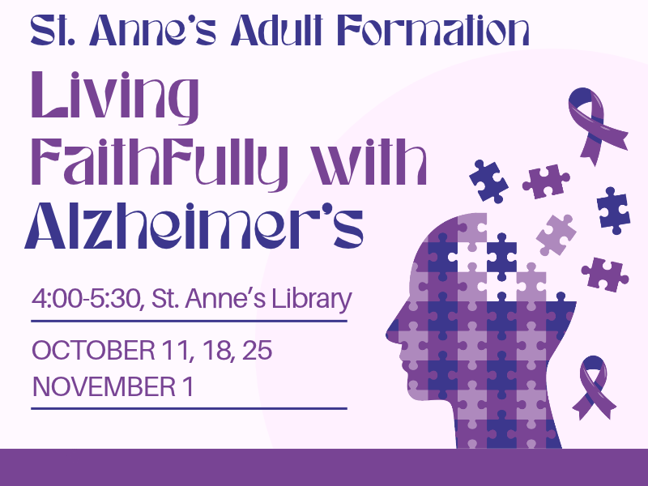
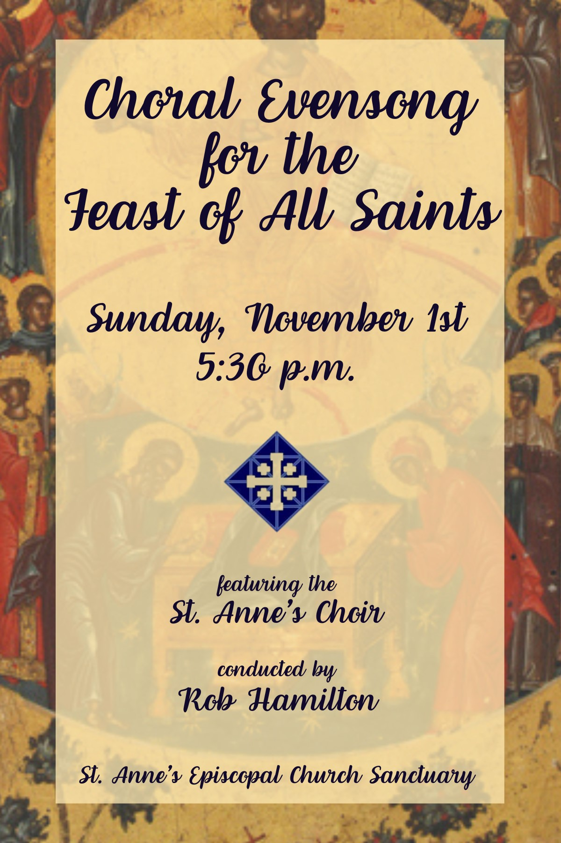
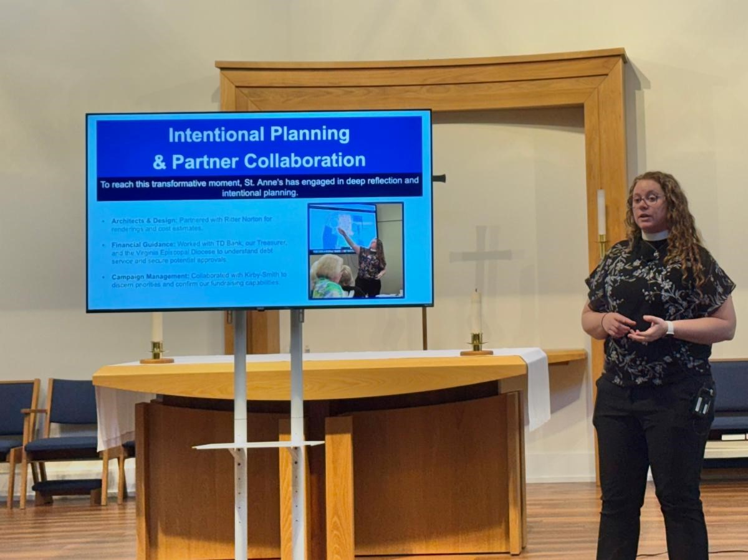

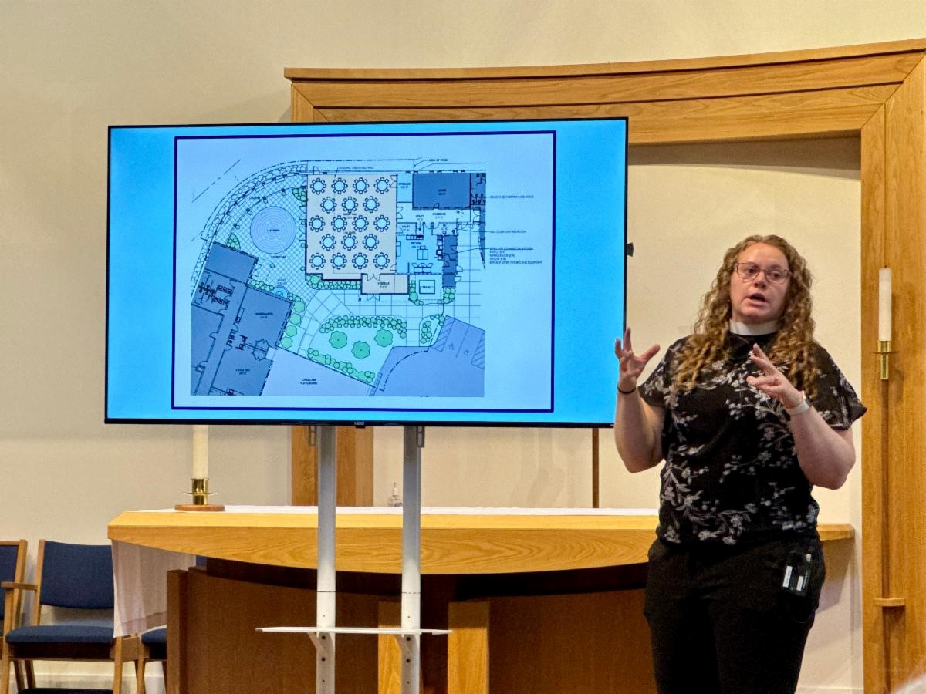
Adult Formation: Living Faithfully
with Alzheimer's
This Sunday, November 1, 4:00-5:30 PM, Library
Online option: Wednesdays at 7:00 PM
via Zoo
m
Join us on Sunday for the 4th and final session in
our "
Living Faithfully with Alzheimer's Series.
"
Featuring
former
Assistant
Bishop
of
Virginia,
Porter Taylor, we will explore the spiritual journey
of living with Alzheimer's through the lens of faith, loss, and gratitude.
We'll discuss the art
of surrender, prioritizing relationships, and we'll end our time together by thinking about
the qualities of a dementia-friendly church.

Questions? Please
reach out to Chris Cameron
.
To see an entire schedule of our Adult Formation Fall offerings,
click her
e
.
Choral Evensong for the Feast of All Saints
This Sunday, November 1, 5:30 PM, Sanctuary
Click her
e

to provide a treat for the reception
k
Livestream Lin
Join us for a special Choral Evensong celebrating the Feast of
All Saints on Sunday, November 1 at 5:30 PM, followed by a
reception.
Click here to
p
rovide a treat or volunteer to se
t
u
p
/clean u
p
.
If you are unable to join us in person,
a
click here to watch vi
livestrea
m
.
You
can
find
the
bulletin
on
St.

s
Anne'
e
home
p
a
g
e her
.
This beautiful and contemplative service is a wonderful opportunity to pause, reflect, and
experience
the
gift
of
sacred
music.
The
service
will
feature
the
St.
Anne’s
Choir,
conducted by Rob Hamilton, in a rich offering of choral music honoring the saints who
have gone before us.
Whether you are a longtime lover of Evensong or have never experienced this beautiful
service, this is an evening you won’t want to miss. Reception to follow the Evensong.
Come. Listen. Reflect. Be inspired.
Youth @ St. Anne's November Calendar

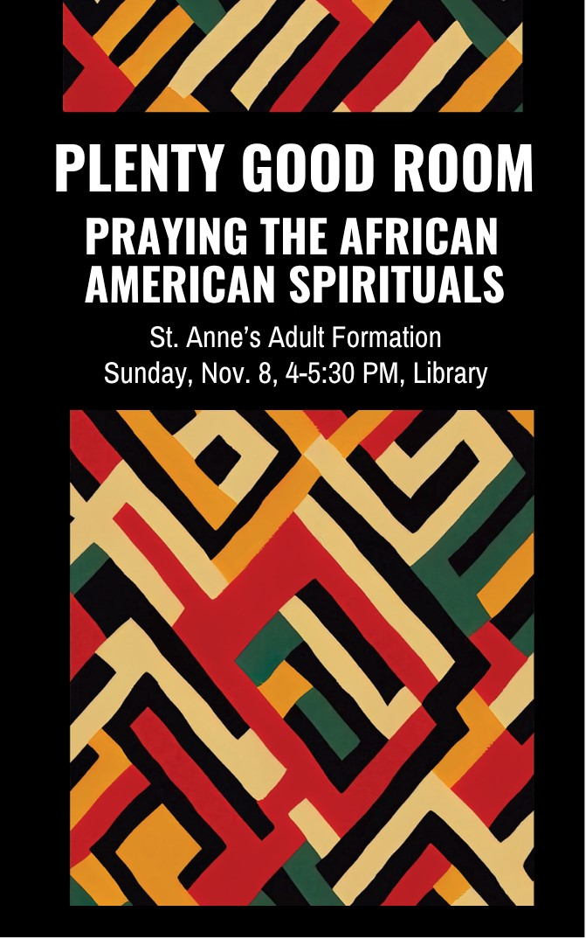

All start at 2:30 PM unless otherwise noted:
November

1:
Student
holiday.
No
youth
@
2:30
,
but
we'll
gather
for
Choral
Evensong
at
5:30
!
PM. We hope you will join us
November
8:

Construction
project
to
serve
Herndon/Reston FIS
H
November 15:
Thanksgiving Drive box sorting
November
22:

Seek
First:
Talking
and
(
Listening) to God
Praying with African American Spirituals
Sunday,
November 8
, 4:00-5:30 PM, Library
The Spirituals were created, prayed, and sung to express a
deep and abiding faith in God and to share stories of the
enslaved. The songs provided hope, comfort and promise of a
better future.
We
will
be
exploring
"
Plenty
Good
Room
,"
our
stewardship
theme
and
an African American
spiritual
turned
gospel
song
that
invites
us
to
recognize
the
abundance
and
radical
welcoming
of
God's
table
and
in
God's
kingdom.
As
we
celebrate the generosity that makes room for all,
choose your
seat and sit down
.
Please reach out to
Mtr Anne
or
Chris Cameron
with questions.
Adult Formation: Making and Praying
with Anglican Prayer Beads
Sunday, N
ovember 22
, 4:00 - 6:00 PM, R
oom 6
Requested donation of $5 per person please
e
Si
g
n U
p Her
Back for a third year! Join us in the sacred process of
making Anglican prayer beads. Mother Anne Cooper will
guide us through the holy purpose and prayer practices
as we use beads to create unique and beautiful pieces of
art to enhance our connection to God.
Click here to si
g
n u
p

so we can be sure we have enough materials for everyone. We are
requesting a donation of $5 to cover materials.

Please bring cash or a check made out to St. Anne's on the day of the class.
There is no charge if you want to come and make beads for use by our priests for pastoral
calls!
Please reach out to
Mtr Anne
or
Chris Cameron
with questions.
Kids Key Moment
This week we heard from our older Sunday school classes about the great friendship
between David and Jonathan, and about what it means to be a friend. From our younger
classes,
we
heard
about
Moses
building
a
place
to
hold
the
tablets
with
the
ten
best
ways.

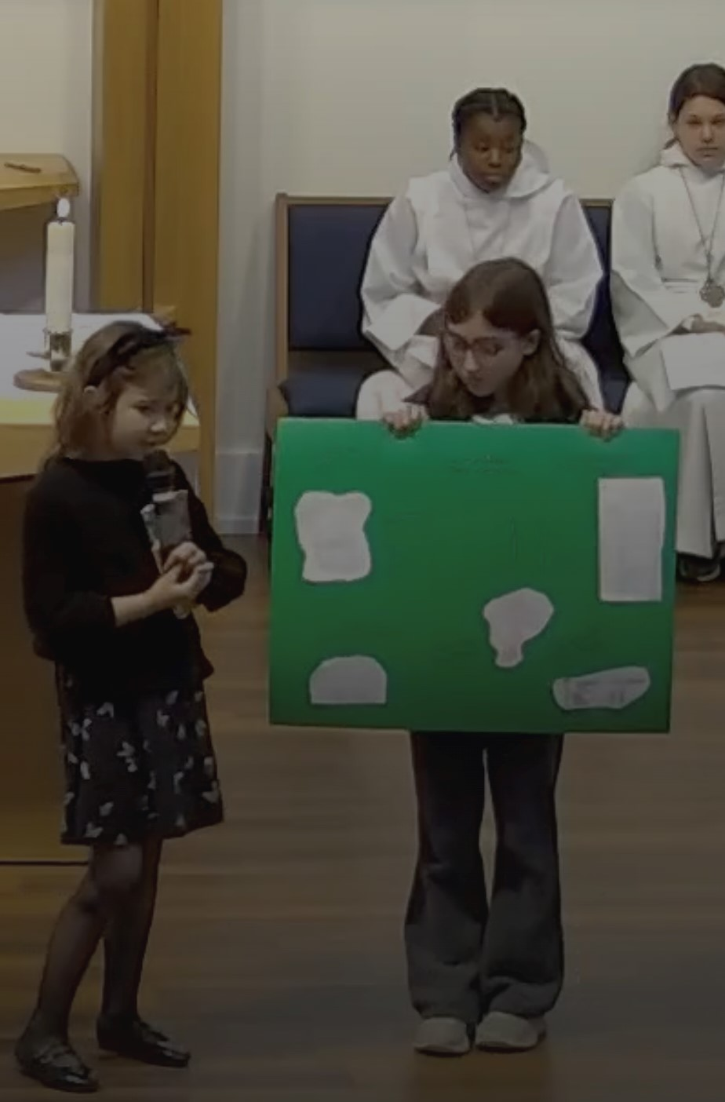
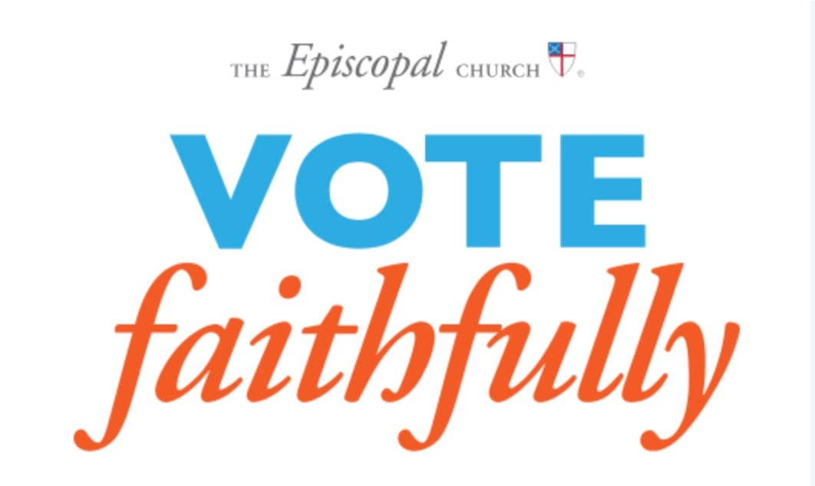

Vote Faithfully
This
Saturday,
October
31
,
is
the
last
day

for
early in-person voting.

If you are voting by mail,
be sure that your completed ballot is deposited in
an
official
drop
box
or
postmarked
on
or
before
Election
Day.

Mail
ballots
must
be
delivered
no
later than noon on the third day after the election.
Visit your county’s Office of Elections website for locations and hours of early voting sites,
locations of mail ballot drop boxes, and your Election Day polling place.
On Election Day, Tuesday November 3, the polls are open from 6 am to 7 pm.

Be sure to
bring your ID.

If you are not registered, you can complete same-day registration and vote
a provisional ballot at early voting sites or your polling place.

For more information on
provisional ballots, visit the state website
vote.vir
g
inia.
g
o
v
.
Virginians will vote on members of the US House of Representative, a US senator and
three proposed amendments to the state constitution.

Some jurisdictions will also vote on
local offices.
The
Prayer
Vigil
list
will
still
be
available
in
the
narthex
for
congregants
this
Sunday, November 1, to choose an hour in which they plan to devote prayer time
for safety and civility during the election. People can pray from wherever they are
for however much time they have. They can also pick up an "I am an Episcopalian
and I voted" sticker in the narthex.
Need a ride to the polls?
Martha Furniss and Dorry Kee will once again organize Souls to the Polls transportation
for
early
voting,
dropping
off
absentee
ballots
or
getting
to
the
polls
on
Election
Day!
Email here to re
q
uest a ride or volunteer to
p
rovide rides
.
Any questions about voting and registration can be directed to
Carol Hurlburt
.
Vote Faithfully Series
Thursday, Nov. 5; 1:30-2:00 PM
On
the
first
Thursday
of
each
month
from
June
through
November,
The
Episcopal
Church's
Public
Policy and Witness team has been hosting a series
of “Vote Faithfully” calls to support voter engagement
in ways consistent with Episcopal values. Next Thursday, Nov 5, is the last one in
the series.

During the calls, hosts share resources and ideas to help congregations promote
voting
and
civic
participation
while
remaining
nonpartisan
(
avoiding
support
for
specific political parties, candidates, or platforms).

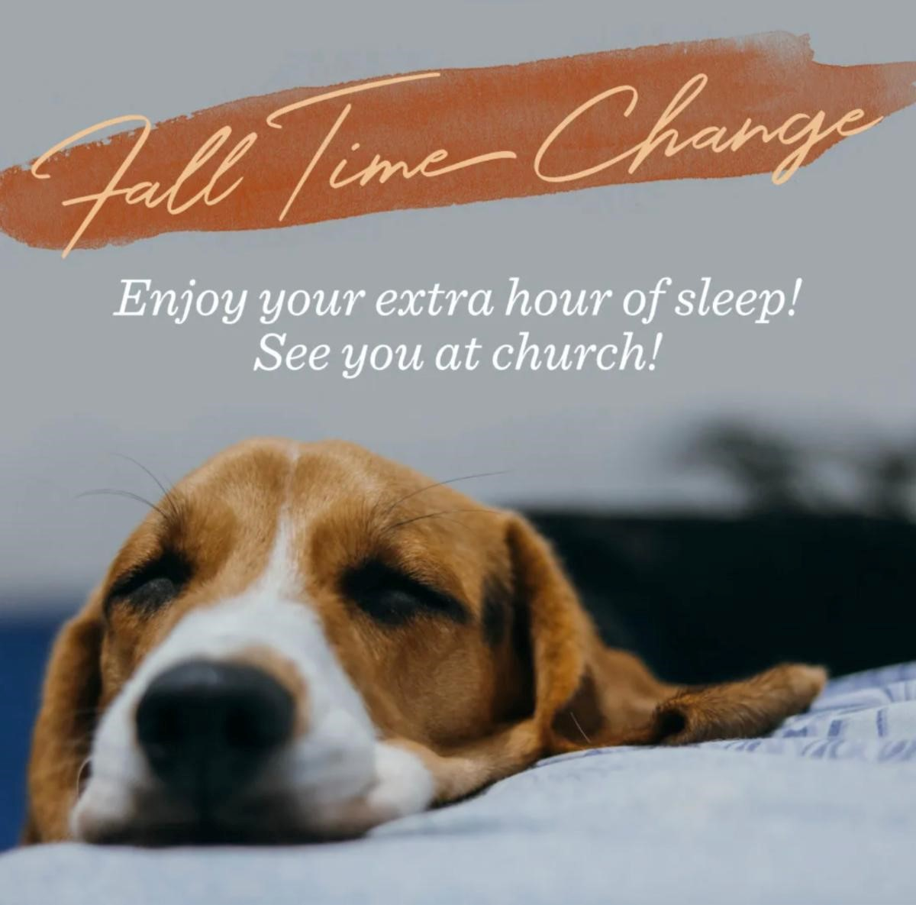
istration and additional information can be found her
g
Re
e
.
Any questions,
reach out to Susan Schreiner
.
Volunteer with The Closet
Try something new! Volunteer with The Closet,
a
well-run
thrift
store
that
gives
back
to
the
community
in
countless
ways.
Its
success
depends
on
dedicated
volunteers,
and
every
helping hand is truly valued.
Volunteer Dates Assi
g
ned to St. Anne's
:
Next Thursday, November 5
Tuesday, December 1
Saturday, December 26

If you and/or a friend might be interested in volunteering, please give it a try! You won't
regret it!
Please feel free to
reach out to Rita Smith
if you have any questions or would
like to join the fun!
comin
g
Closet Date to Save
Other U
p
:
December 12: Winter Market
Don't Forget to Fall Back Saturday
Night!
Just
a
reminder
to
set
your
clocks
back
one
hour
on
Saturday night, otherwise you might get to St. Anne's
extra
early
on
Sunday
morning
and
wonder
where
everyone is!
Seen Around St. Anne's
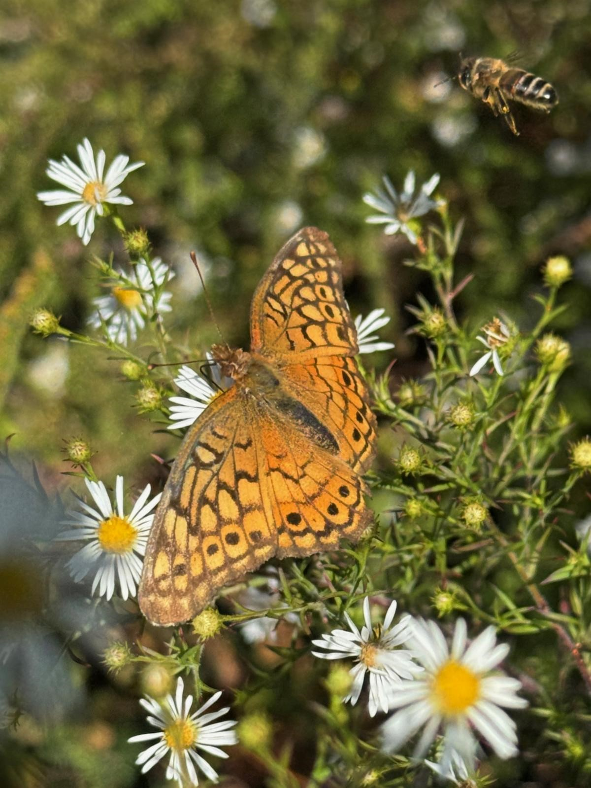

Check out this absolutely gorgeous photo,
taken by Martha Furniss, in the front yard
pollinator garden last Sunday morning!
Can you spot the bee? Thanks for sharing,
Martha!
Can you spot the yellow butterfly in our St.
Anne's pollinator garden?
St. Anne's Vestry
Daria Antonucci, Sarah Brummett, Bernadette Capelle, Marian Egge, Rosie Horn (Jr Warden), Brandon Huffman,
Margaret Light (Sr Warden), Christian Pelfrey, Suzanne Robinson, Nancy Santoro, Matt Scott, The Very Rev.
Jessica Holthus (Rector & Chair), The Rev. Kara Laughlin (Associate Rector for Discipleship)
Contact Us
The Ver
y
Reverend Jessica Holthus
, Rector
The Reverend Kara Lau
g
hlin
, Associate Rector for Discipleship
Robert Hamilton
, Music Director
g
Mar
g
aret Li
ht
, Senior Warden
Sheri Schaffer
, Parish Administrator
An
g
ie Gray
, Office Administrator
Our offices are open Monday through Friday from 9:00 am to 3:00 pm. We are available by
phone and email at other times. We check the office voicemail at (703) 437-6530 regularly.
Have an announcement? Need to reserve space?
The
deadline
to
submit
an
announcement
for
enews
is
12:00

pm
on
Tuesdays
.
Email it to Sheri
.
In addition to the text of your announcement, include graphics, photos
and links in your email.
To
reserve space at St. Anne's for an upcoming meeting/event,

email Sheri
with the
date, time and number of people you expect in attendance.




Was this newsletter forwarded to you?
Sign Up For Enews
!
St. Anne's Episcopal Church, Reston |
1700
Wainwright Drive
|
Reston, VA 20190-5500 US
Unsubscribe
|
Update Profile
|
Constant Contact Data Notic
e

