
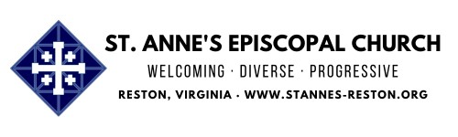
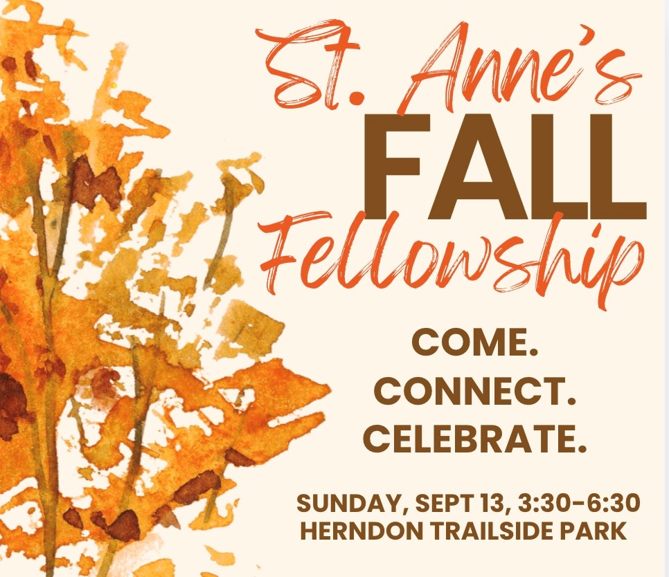
To see the whole newsletter in your browser
click her
e
Access Our Website for Worship Link
s
Fall Fellowship
Sunday, September 13, 3:30-6:30 PM, Herndon Trailside Shelter, 1022 Crestview
Drive
Come
join
us
for
our
congregation-wide
Fall
Fellowship
at
Herndon
Trailside
Shelter on Sunday, September 13 from 3:30-6:30 PM.
This event kicks off our exciting program year in the spirit of "Community!" And
what a fabulous community we have! There will be food, fellowship, games, music
and prayers.
Si
g
n u
p
her
e
to bring a side dish or dessert or volunteer to help with parking, set
up and/or clean up.
See map below for location and parking information (courtesy of Chris Korbuly).
You can click on it and download it. We will also have copies at church for you.

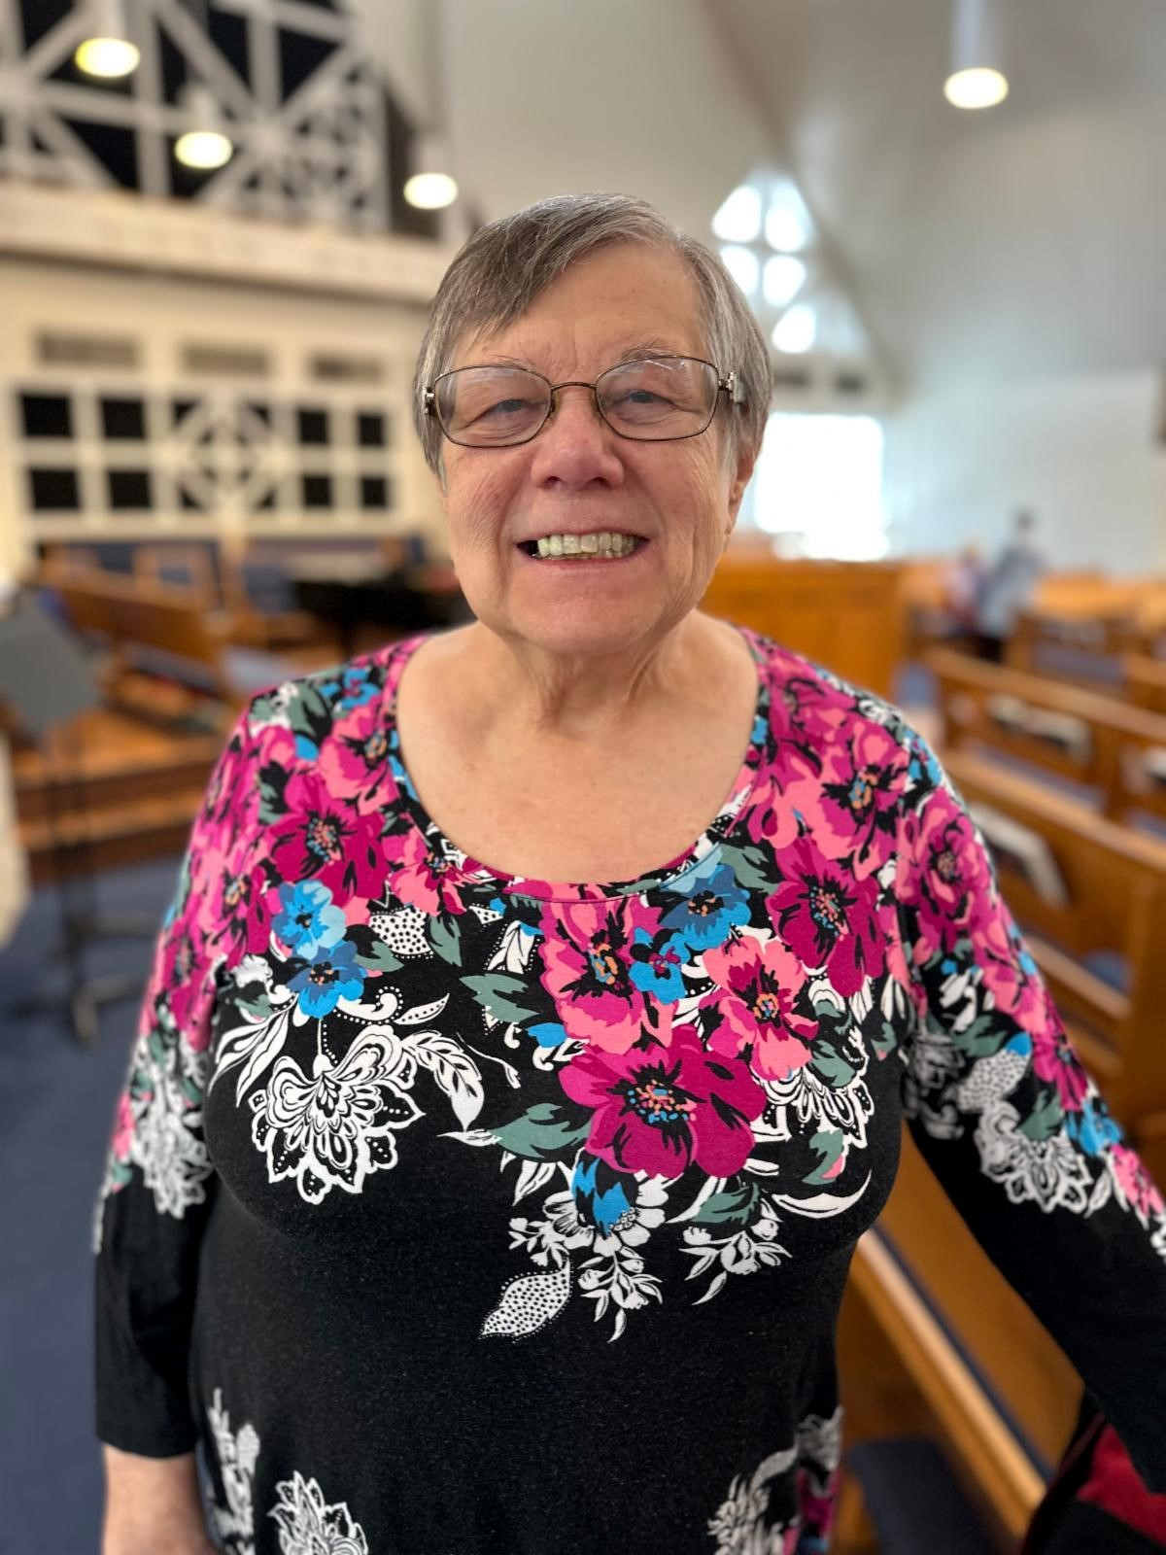
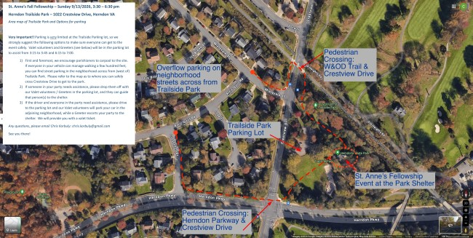
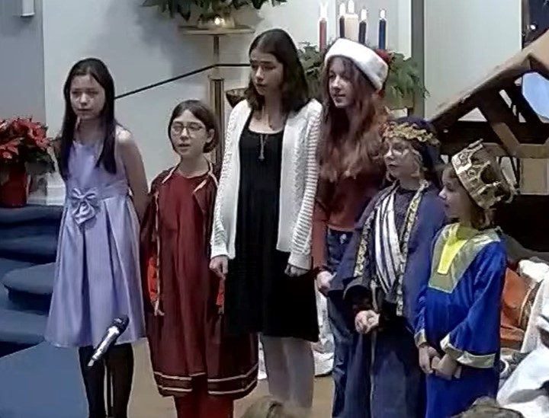
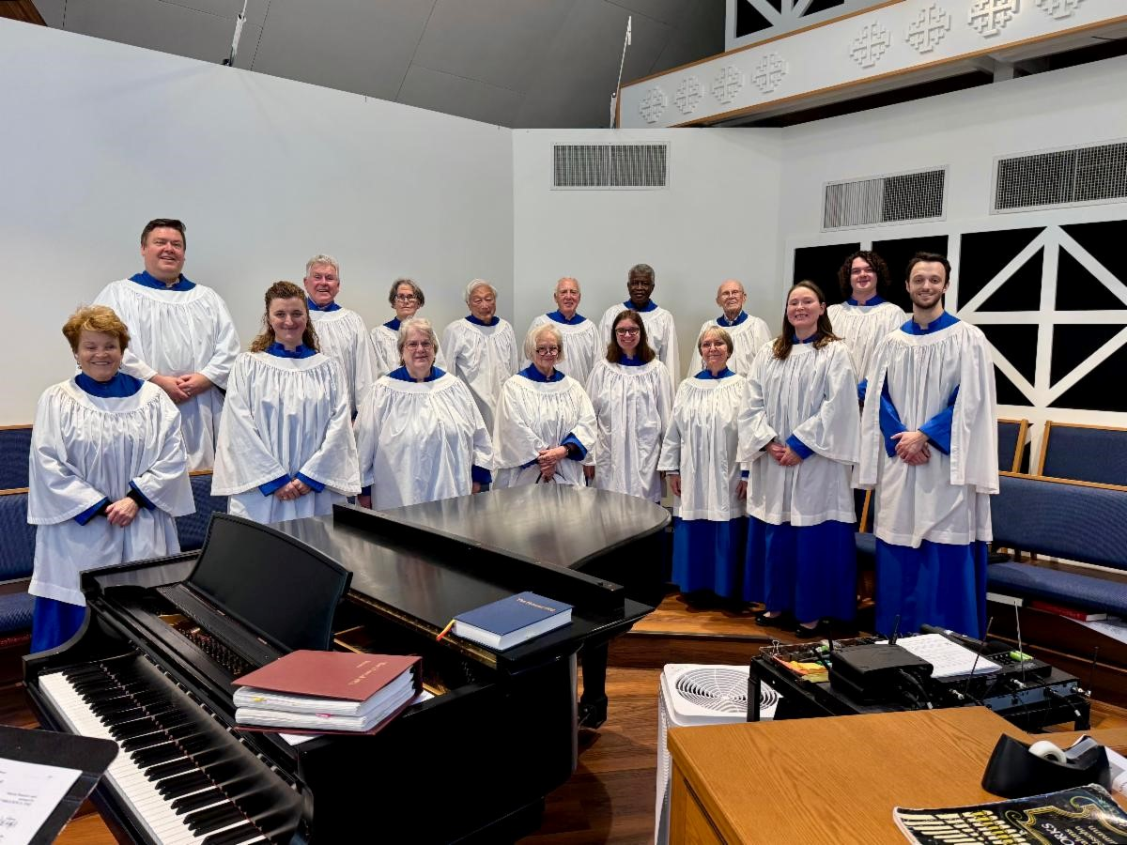
Junior Warden Update
We’re
thrilled
to
announce
that
Rosie
Horn
has
graciously
accepted the position of Junior Warden, serving through our
next Annual Meeting in February.
Rosie is stepping in for Cat Tucker, who resigned earlier this
year due to family obligations. We’re grateful to Cat for her
service and grateful to Rosie for her willingness to step into
this important role.
Thank you, Rosie, for saying yes! We’re so glad to have you
serving in this role.
ALL GOD'S CHILDREN HAVE A PLACE IN THE CHOIR!
St.
Anne’s
Choristers
is
welcoming new members for the
upcoming
church
year!
All
children
and
youth
in
Grade
3
and up are invited to join.
Rehearsals
:
Sundays after the
AM service (approx.
10:00
45
minutes).
Singing in Church
About once a
:
month.
St.
Anne’s
Choir
is
always
looking for new voices to join our
musical
ministry,
whether
you're
a soprano, alto, tenor, or bass!
As
we
prepare
for
the
new
program year, now is the perfect
time
to
get
involved.
Rehearsals
are
held
on
Wednesdays
from
7:00

to
9:00

PM,
and
Sunday
mornings
at

9:00
AM
before
the
service.
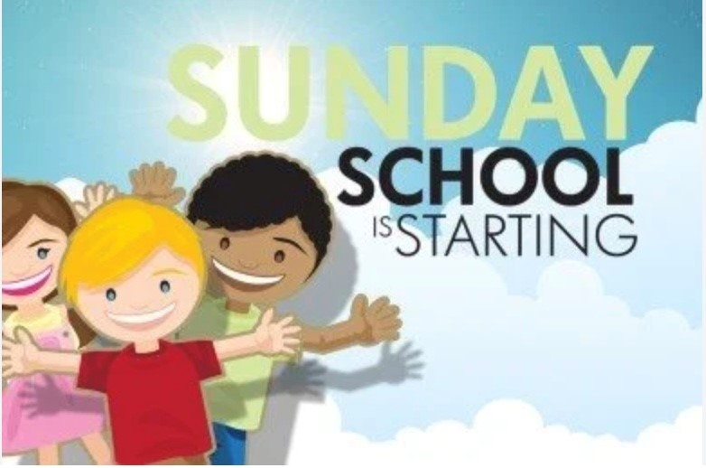
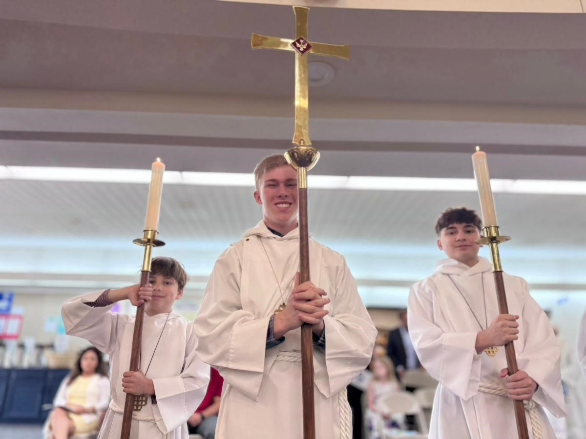
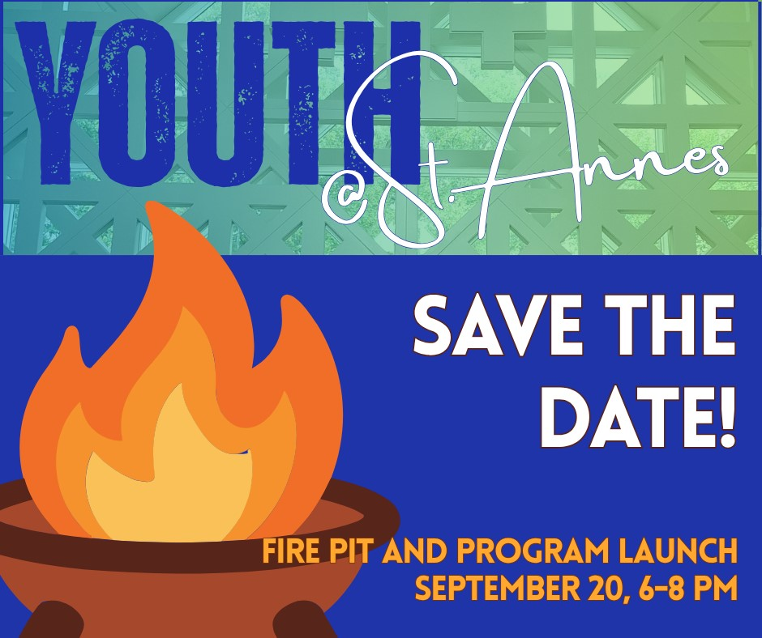
First Rehearsal
Sunday,
:
September 13. No prior
experience needed...just a love
for music and a willingness to
participate!
How to Join?
If your child is
interested, please speak to Rob
after a service or
email him
.
If
you're
interested
in
joining
or
would
like
more
information,
please
speak
with
Rob
after
a
service
or
reach
out
to
him
via
email
.

2026-27
Sunday School & Youth Group
p
e
n
Re
g
istration Now O
!
We are so excited to begin our new program year on
September
13
th!
Parents,
please
take
a
moment
to
register your child(ren) for Sunday School (Pre-K–6th
grade) or Youth Group (6th–12th grades). We ask all
families to complete a new registration each year, even
if you’ve registered in the past.
r
Click here to re
g
iste
. We look forward to a joyful year of faith, learning, and community!
Acolyte Training
September 13, following the 10 AM service
We
will
be
hosting
an
Acolyte
Training
session
on
Sunday, September 13, immediately following the 10:00
AM service.
This
training
session
is
for
both
current
acolytes
and
prospective
acolytes
who
are
interested
in
serving
in
this important ministry. The session will cover the responsibilities of an acolyte, the order
of service, and practical instruction for serving during worship.
If you are interested in becoming an acolyte, please email
Seward Coo
p
er

and
Mother
Kara
.
We look forward to seeing you there!
Youth Launch Save the Date
Sunday, September 20, 6:00-8:00 PM, St. Anne's Parking
Lot
All youth between 6th and 12th grade are invited to bring
their parents to our
Fire Pit and Program Year Launch
for youth ministry at St. Anne's!
Come meet our leadership team, find out about service
projects
and
gatherings
we
already
have
planned,
and
make
your
voice
heard
as
we
brainstorm
the
schedule
for
the
rest
of
the
year!
We'll
provide
food
(
and
not
just
stuff
for
S'Mores),
and
plenty
of
time
to
reconnect
with
St.
Anne's friends.

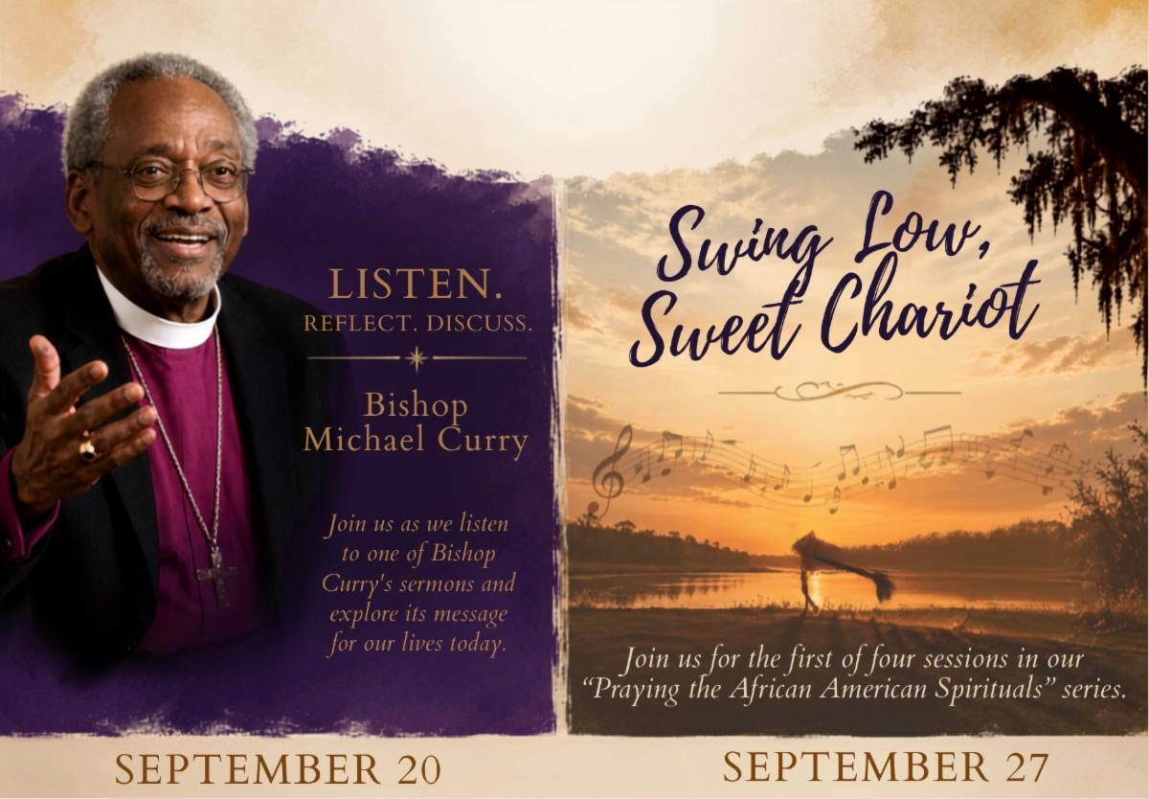
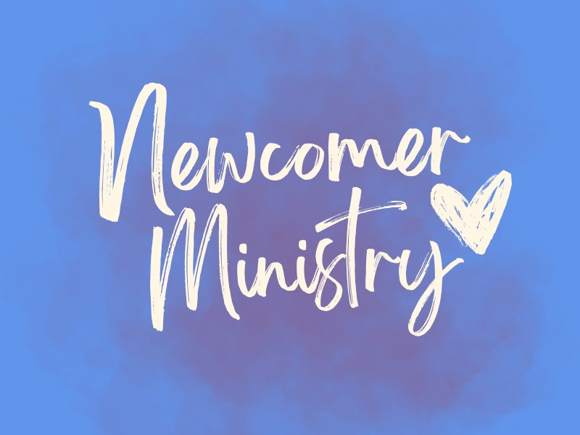
Adult Formation is Almost Here!
Sunday, September 20, 4:00-5:30 PM, Library
Sunday, September 27, 4:00-5:30 PM, Library
Mark
your
calendars
for
the
first
two
of
many
fabulous adult formation opportunities coming this
fall!
First up
:

Sunday, September 20, 4:00–5:30 PM
Join us as we listen to a contemporary, influential
sermon from former Presiding Bishop Michael Curry and explore how its message speaks
to our own ministry.
Next up
:

Sunday, September 27, 4:00–5:30 PM
We’ll begin the first of four sessions in our
Praying with the African American Spirituals
series.
We're thrilled to kick off the series with
Swing Low, Sweet Chariot
, an African
American Spiritual and well known Christian hymn on September 27.
We’re so excited to continue this popular series for a fourth year, with two sessions this
fall and two more in the spring. You can expect opportunities to engage with our country’s
history and faith through music while expanding and deepening our racial justice ministry.
Questions about either offering? Please
reach out to Chris Cameron
.
Help Us Welcome Our Newcomers
St. Anne’s is known for its warm and welcoming spirit,
and as we reinvigorate our Newcomer Ministry, we’d
love to build on that tradition of hospitality.
We are looking for volunteers at each service to serve
as
a
designated
Newcomer
Greeter.
The
role
is
simple: after the service, spend a little time chatting
with people who are new to St. Anne’s or visiting for
the first time and would like to learn more about our church. We’ll provide some helpful
guidelines
and
suggestions
for
how
to
engage
with
newcomers
and
make
them
feel
especially welcome.
Our hope is to have enough volunteers that each person would only need to serve once
every six weeks or so, making this an easy and meaningful way to help St. Anne’s live out
its welcoming spirit.
If you’re interested in volunteering or would like more information, please reach out to
Daria Antonucci
or
Nanc
y
Santoro
. We’ll use SignUpGenius to coordinate the volunteer
schedule.
Thank you for helping us make sure everyone who walks through our doors feels truly
welcomed and at home at St. Anne’s!
Advocacy Ministry Meeting
Sunday, September 13, after 10 AM service, Library
Please join us on Sept 13 after the 10am service in the Library as we gather to reflect on
work done and what we want to accomplish for Fall & Winter 2026.

If you are not yet on the Advocacy Ministry email list please
let Susan know
and we will
get you added.
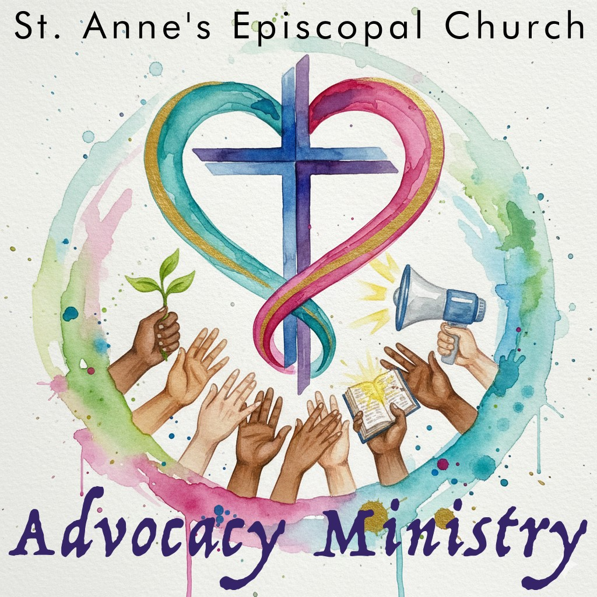
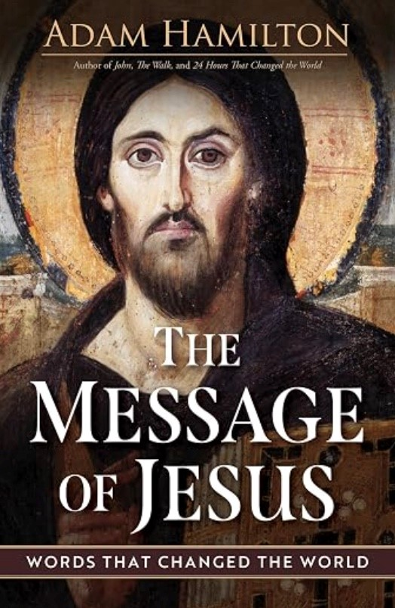

Hope to see you there!
Arlington Interfaith Vigil against ICE cruelty
Saturday,
September
19
,
vigil
and
optional
procession
Alcova Heights Park - 2:00-4:00 PM
This interfaith public ritual will lift up the memory of those
whose lives have been taken unjustly by our own country, a
matter of sorrow and shame, and of supreme importance to
call out in this national emergency.
Together we will honor the over 50 people who have died by
the hands of ICE or in ICE custody since 2025 along with
the 15K+ people taken in by ICE in Virginia, 76% having no criminal record.
We
will
gather
to
hear
from
faith
voices
proclaiming
the
importance
of
justice
and
welcome, and we will remember the names of those we have lost. An optional procession
will then go through the neighborhood carrying signs with the names and faces of those
who have died. Signs will be provided. Come to join in community and act in public for
what is right.
Monday Morning Bible Study
Monday, September 14, 10:30-12:00 via Zoom
The Monday Morning Bible Study will resume on Monday, Sept. 14,
via Zoom, 10:30 a.m. - 12:00 p.m.

We will begin the semester with
The Message of Jesus
by Adam
Hamilton (one of our favorite authors).

Class
format
is
a
brief
video
by
the
author
followed
by
class
discussion.

The book is available on Cokesbury and Amazon.
To join the fun
contact Jane Smith
.
St. Anne's Book Club (In Person!)
Monday, September 14, 12:00 PM, Room 6
Bring your own lunch!
Join us for an in-person book discussion of
The Coming Wave
by
Mustafa
Suleyman
on
Monday,
September
14
,
in
Room
6

at
St.
Anne's. Bring your own lunch.
A
co-founder
of
DeepMind,
Suleyman
explores
how
artificial
intelligence and other rapidly advancing technologies are poised to
transform our world, bringing extraordinary opportunities as well as
profound challenges. Together, we'll discuss what this technological
wave could mean for our future and how society might navigate the road ahead.

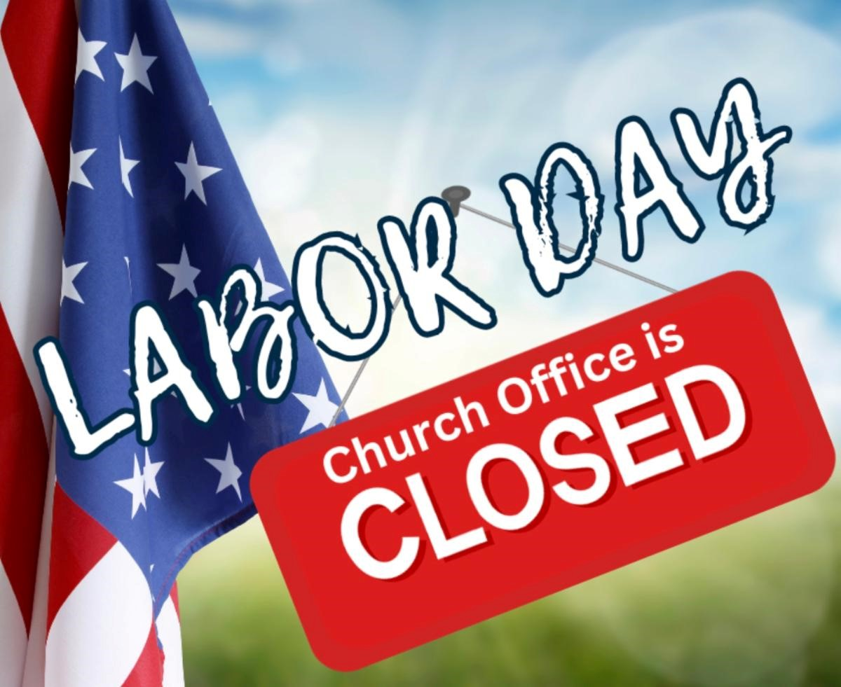

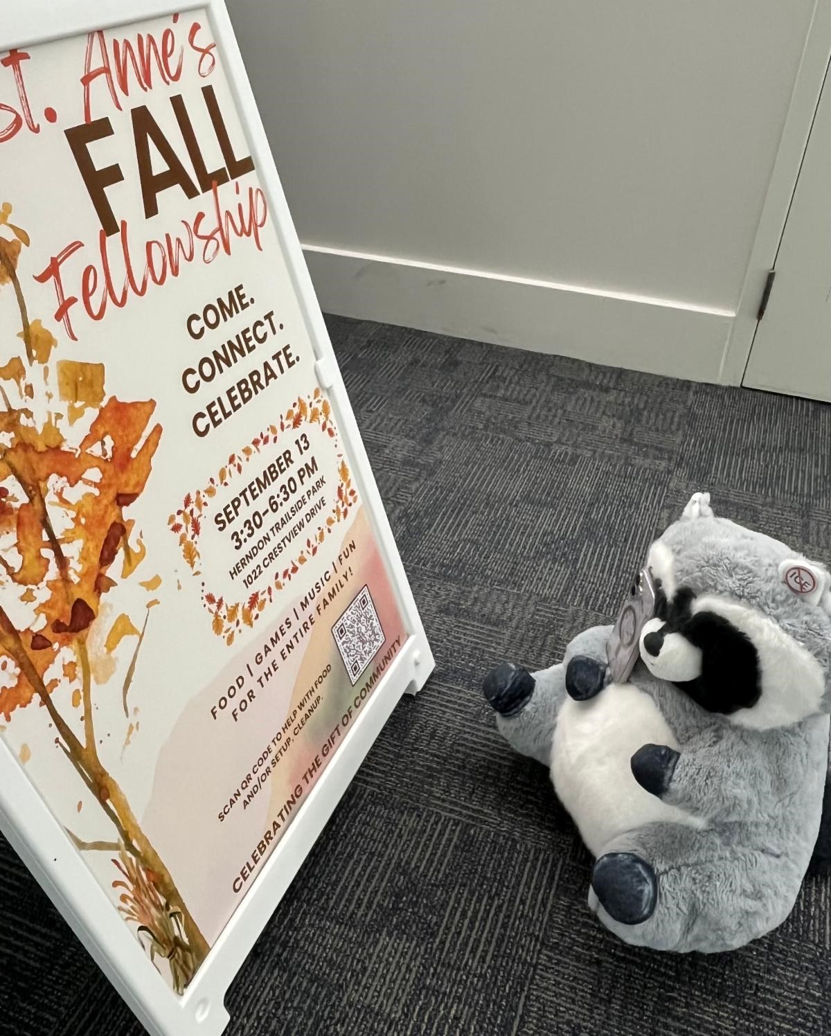
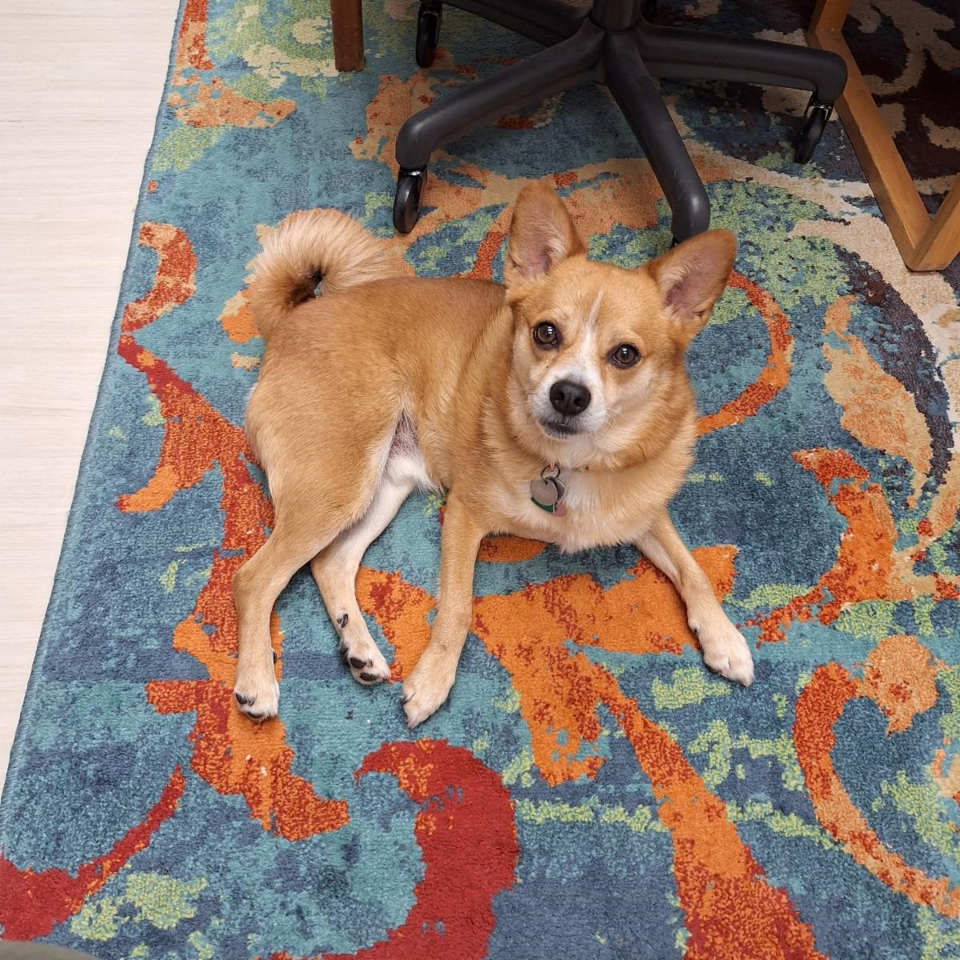
Whether
you've
read
every
page
or
just
want
to
join
the
conversation,
all
are
welcome!

Any questions,
reach out to Don Boileau
.
Passport to Fun This Summer - Hooray!
Only Two More Sundays to grab your passports!
Two more Sundays to grab your passports!
Attention, Sunday Schoolers! We hope you've had fun
Journeying with Jesus this summer! This week is your last
chance to fill in your Summer Passports! We will gather all of
the passports, count the stamps, and award prizes at our Fall
Fellowhip Celebration on September 13!

St. Anne's Closed on Monday
If you have a pastoral emergency, please call the church
office and someone will get back to you.
Wishing you a safe and enjoyable Labor Day.
Seen Around St. Anne's
Gratitude to Emily Muha for
compiling our St. Anne's
memory book for Wilson and
Charlie. Mtr Jess delivered
the book to Mtr Laura's
family earlier this week.
Remy the Raccoon is getting
ready for Fall Fellowship on
September 13! He’s
scanning the QR code to
sign up to bring a treat - and
you can too!
Click here t
o
n u
si
g
p
and help make our
gathering extra special.
Meet Remi, Mtr Kara's sweet
pup! He got to spend a
couple days at St. Anne's
last week as our resident in
training! But turns out Remi's
idea of a productive day is
looking adorabale and
"barking" orders!
St. Anne's Vestry
Daria Antonucci, Sarah Brummett, Bernadette Capelle, Marian Egge, Rosie Horn (Jr Warden), Brandon Huffman,
Margaret Light (Sr Warden), Christian Pelfrey, Suzanne Robinson, Nancy Santoro, Matt Scott, The Very Rev.



Jessica Holthus (Rector & Chair), The Rev. Kara Laughlin (Associate Rector for Discipleship)
Contact Us
The Ver
y
Reverend Jessica Holthus
, Rector
The Reverend Kara Lau
g
hlin
, Associate Rector for Discipleship
Robert Hamilton
, Music Director
ht
g
Mar
g
aret Li
, Senior Warden
Sheri Schaffer
, Parish Administrator
An
g
ie Gray
, Office Administrator
Our offices are open Monday through Friday from 9:00 am to 3:00 pm. We are available by
phone and email at other times. We check the office voicemail at (703) 437-6530 regularly.
Have an announcement? Need to reserve space?
The
deadline
to
submit
an
announcement
for
enews
is

12:00
pm
on
Tuesdays
.
Email it to Sheri
.
In addition to the text of your announcement, include graphics, photos
and links in your email.
To
reserve space at St. Anne's for an upcoming meeting/event,

email Sheri
with the
date, time and number of people you expect in attendance.

Was this newsletter forwarded to you?
Sign Up For Enews
!
St. Anne's Episcopal Church, Reston |
1700
Wainwright Drive
|
Reston, VA 20190-5500 US
Unsubscribe
|
Update Profile
|
Constant Contact Data Notic
e

